Analysis Me

**Fall**

2015

Technical Report

Service Oriented Computing (18-655)

Team 5

Enclosed in this document is the technical report of the Workflow and User System sponsored by NASA/NSF/Apache.

Table of Contents

1 Introduction 2

2 Motivation 3

3 Related Work 3

3.1 Docker Environment Setup 3

3.2 Getting Familiar with Play Framework 3

3.3 Learning Hibernate 3

4 System Design 4

5 System Implementation 5

5.1 Workflow Detailed Description 5

5.2 Workflow popularity 7

5.3 User Login System 8

5.4 User Access Control and User Groups 8

5.5 Friend List 10

5.6 Subscribe 11

5.7 User Profile 12

5.8 Tagging 14

5.9 Forums 14

5.10 Discussion or Question 14

5.11 Moderator Rights 14

6 Experiment and Analysis 15

7 Conclusions and Future Work 20

8 Contribution of Each Team Member 21

9 Tutorial 21

Appendix 30

# Introduction

This project constructs a backend API for scientific workflows social network. In workflow-centric scientific social network, scientists can publish and share their experiments in the form of scientific workflow, and they are able to communicate on the basis of the workflow. For example, a user can create a workflow with basic information such as workflow description, tasks, inputs and outputs, links and instructions, associated datasets, then this user can add contributors (other users that contribute to this workflow) to share this workflow. Also, user can add other workflows that attribute this workflow. Furthermore, this project contains features such as user login system, user access control based on user groups, user friend list, subscribe, user profile, tagging, forums, mark post as discussion or question, mark reply as answer, moderator rights and so on.

# Motivation

Building a workflow-centric scientific social network allowing scientists to communicate and share their ideas of a scientific project in a more effective and productive way. They can comment on the entire workflow, and collect the ideas from the other scientists to help improve their research. Furthermore, user can organize collaborators with self-defined access control, making the whole scientific process clearer and more organized. User can tag workflows and posts, so when they are interested in a specific topic, they can go through the workflows and posts that are related very quickly. Workflow-centric scientific social network brings many benefits to the process of scientific research, and this is the reason why we devote ourselves on this project.

# Related Work

## Docker Environment Setup

Docker is an open platform for distributed applications for developers and system administrators. This project can be run and test on Docker, setting up the docker environment is required for running the project. Detailed step for installing Docker is available on Docker official site: <http://docs.docker.com/mac/step_one/>

## Getting Familiar with Play Framework

This project is constructed on play framework. Play framework makes building web applications with Java and Scala easier. Getting familiar with the play framework and the project structure that build on Play is important for understanding the code of this project. The video Introduction to Play Framework for Java Developers provided by Play’s official sites gives us a start point for using play framework: <https://www.youtube.com/watch?v=bLrmnjPQsZc>

## Learning Hibernate

Knowledge of Hibernate is the key to program this project, it’s used for mapping an object-oriented domain model to a traditional relational database. Understanding Hibernate Mapping is very important, which includes one to one mapping, one to many mapping, many to many mapping, self-join many to many mapping. These mapping in this project are specified to annotation mapping, not XML mapping, the tutorial from the following links serves as a basis for constructing the entities relationship for this project: <http://viralpatel.net/blogs/introduction-to-hibernate-framework-architecture/>

# System Design

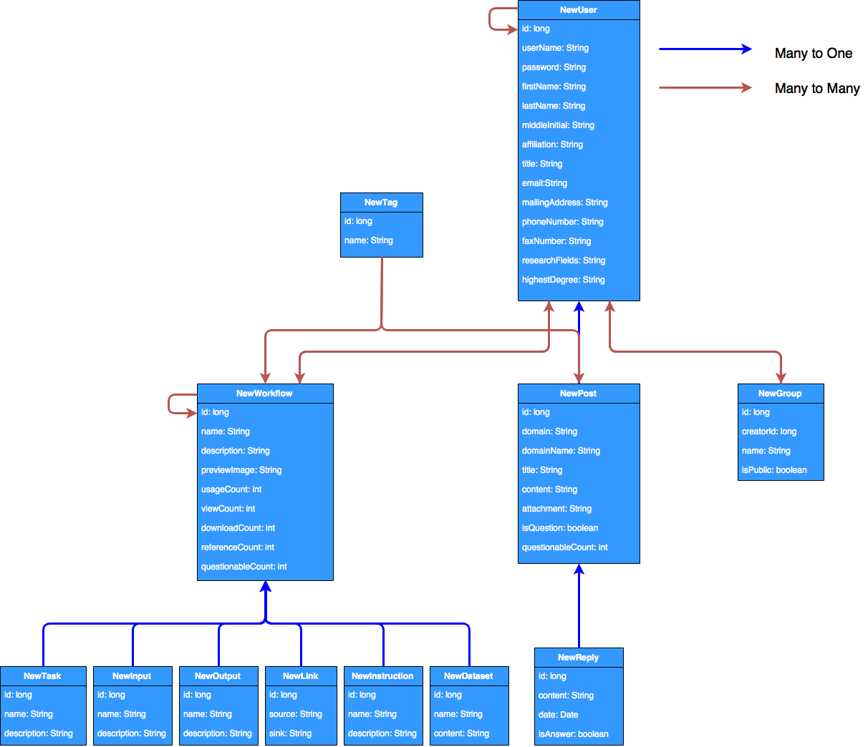

Figure ‑

Figure 4-1 shows the database schema design for the backend of the project. The blue arrow represents many to one relationship, and red arrow represents many to many relationship.

First of all, we can see that one workflow can have many tasks, inputs, outputs, links, instructions and datasets, it’s a relationship of one to many. The workflow table has self-join many to many relationship, because a workflow can contain many other workflows that attribute to this workflow, and those other workflows can also have their own attribute workflows. What’s more, the relationship between user and workflow is many to many, because a user can have many workflows, and a workflow can contain many users.

Second, let’s see the Post table, all posts in this project are organized as one discussion tree with a single root associated with a workflow, group or service. The relationship between post and workflow/group/service is not defined through the relationship between the tables, instead, I use two fields in the post table to specified the relationship. The “domain” field in the post table can only have one of these three values: workflow, group or table, which defined where the post belongs to. The second field is the “domainName”, this field records the corresponding workflow’s name, group’s name or service’s name that map to this post. In fact, the relationship between workflow/group/service and post is one to many, I didn’t use hibernate to map these relationships because it will complicate the database. The relationship between post and reply is one to many, and the relationship between user and post is one to many too.

Third, the relationship between tag table and workflow/post table is many to many, because one tag can contain many workflows and posts, and one workflow or one post can have many tags.

Forth, user table have self-join many to many relationship because user can add other users as friends, and these friends are users that can have other users as their friends. The second reason why user have self-join relationship is that one user can subscribe other users, the mechanism is quite the same as friend relationship, but not require any approval action on the other user’s part. Furthermore, one user can subscribe workflows and groups, these are also the reason why the relationships between user and workflow/group are many to many.

Finally, in this project, user access control is accomplished through user groups, the relationship between user table and group table is many to many, because one user can have many groups, and one group can contain many users that are classified as admin users or member users.

# System Implementation

In this chapter, I will go through the implementation of the suggested feature list one by one.

## Workflow Detailed Description

A workflow can be displayed in a single summary page that can include a short text description, image preview, workflow component tasks, input and output, contributors, tags, links and instructions, associated datasets, other workflows that attribute this workflow.

In this project, text description and image preview are defined as a column in the workflow table (Figure 5-1).



Figure ‑

Workflow components tasks, input and output, links and instructions, associated datasets are tables that have many to one relationship to workflow table (Figure 5-2), please notice that once the workflow is deleted, this tasks, input, output, links, instructions and datasets will also be deleted, because orphanRemoval is set to be true.

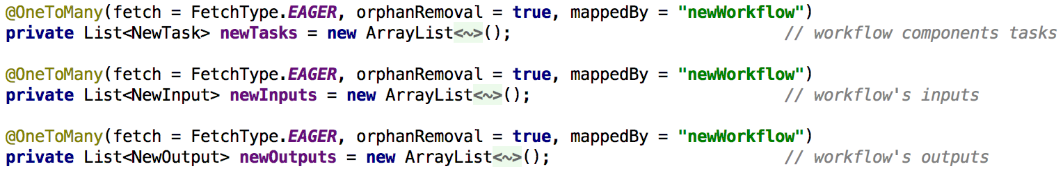

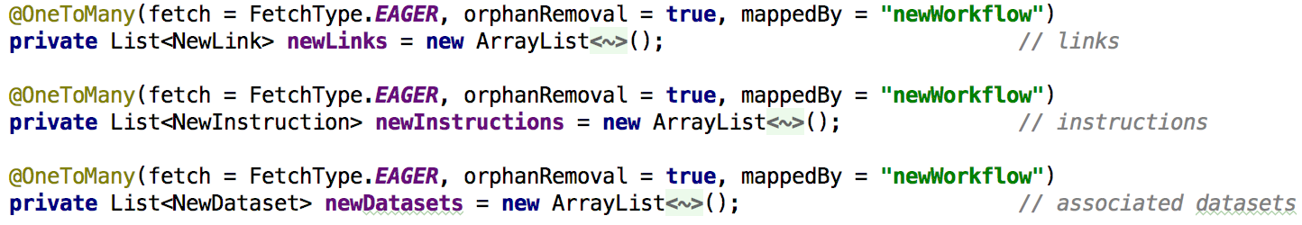

Figure ‑

For the contributors, which are users that contributes to the workflow, has many to many relationship with the workflow table, Figure 5-3 is the contributor defined in the workflow table, and Figure 5-4 is the corresponding fields that defined under the user table.



Figure ‑

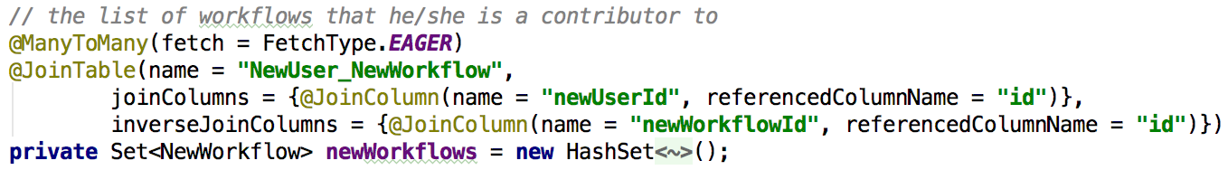

Figure ‑

For tags, in the feature list of this project, tags can be added to workflows and posts, furthermore, workflows and posts can also be searched by tags. So I construct a tag entity that have the following fields (Figure 5-5)

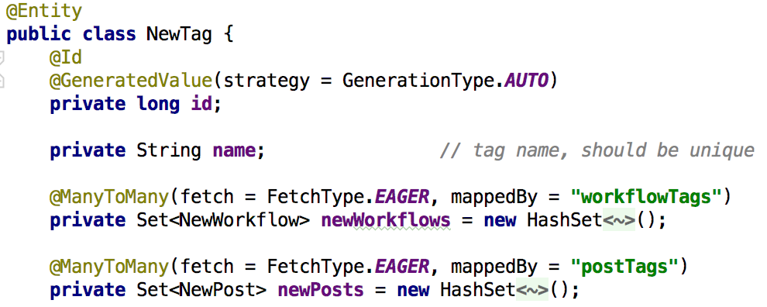

Figure ‑

From figure 5-5 we can see that a tag with a specific name can contain many workflows and posts, so workflows and posts can be easily searched by the tag name using Hibernate. Accordingly, in the workflow entity (Figure 5-6) and post entity (Figure 5-7), they also have fields that map to the tag table.

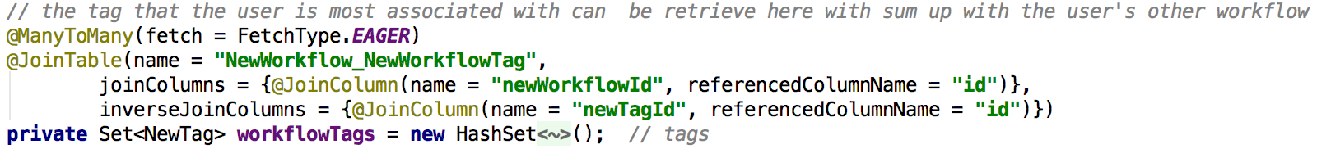

Figure ‑

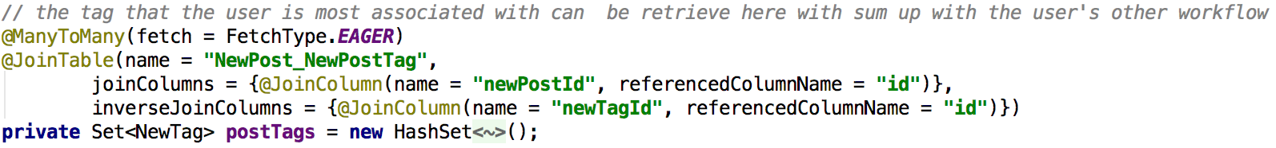

Figure ‑

Finally, for the other workflows that attribute this workflow, it’s a self-join many to many relationship between workflows. It’s defined and mapped under the workflow entity (Figure 5-8)

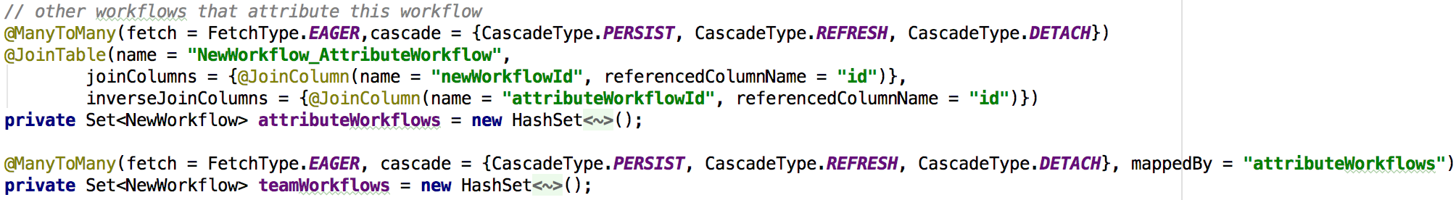

Figure ‑

## Workflow popularity

Workflow popularity can be displayed as a function of number of usages, view count, comment count, download count, reference count. For usages, view count, download count and reference count, they can directly retrieve from the workflow entities’ field (Figure 5-9)

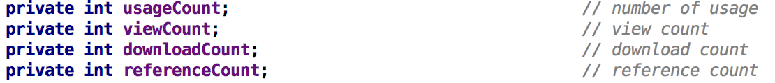

Figure ‑

But for the comment count, it has to be calculated from all the comments under all the posts under this workflow, Figure 5-10 shows the algorithm to calculate the popularity of the workflow.

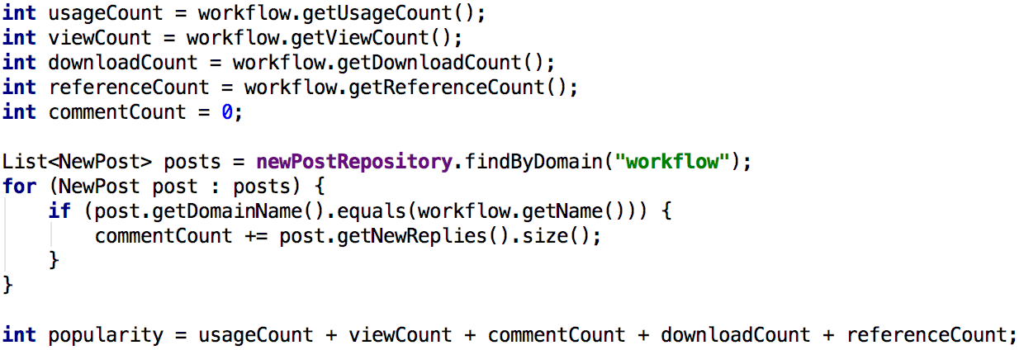

Figure ‑

## User Login System

For register, the basic idea is to create a user instance with fields of user name, password, first name, last name, middle initial, affiliation, title, email, mailing address, phone number, fax number, research fields, highest degree, then add this user instance to the database through hibernate.

For login, what we need is the user’s email and password and check where they match the records in the database, if matched, the user is valid for login (Figure 5-11)

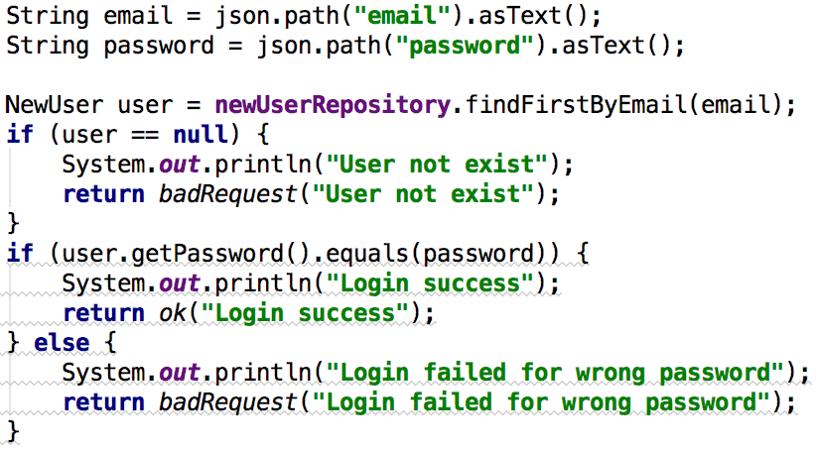

Figure ‑

## User Access Control and User Groups

The user access control in this project is achieved through user group, so I combine these two features and implement in this project as the group entity. Let’s take a look at the group entity (Figure 5-12).

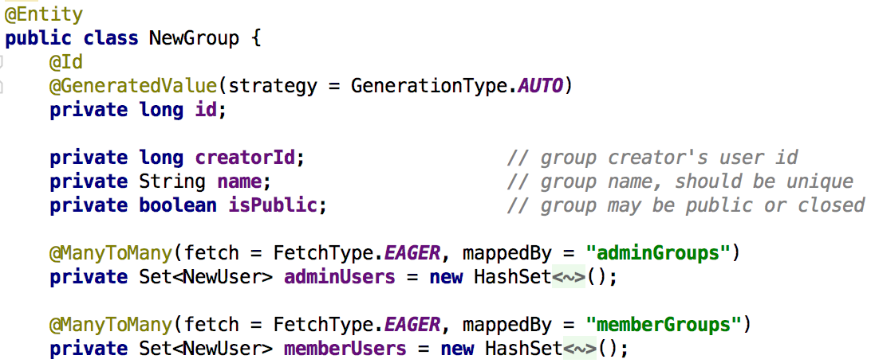

Figure ‑

A group has a creatorId to mark down the user id that create this group. A group has a name, and a isPublic field the defined whether this group is public or closed.

The key point of the access control is that one group maintains a set of admin user and a set of member users, admin user and member should have different authority.

Correspondingly, under the user entity, we also have fields that map the relationship with the group (Figure 5-13)

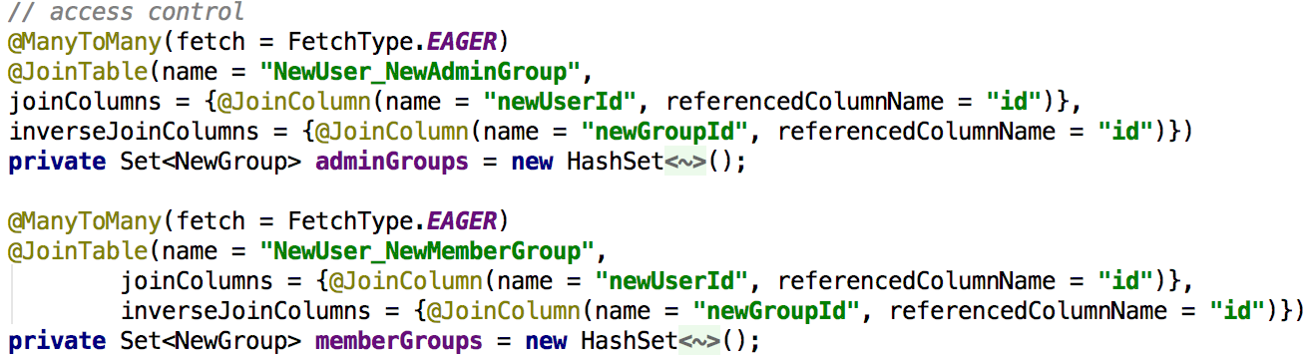

Figure ‑

When you want to add one user to one group as a administrator, you can call /user/addUserToGroupAsAdmin API, same as add one user to group as member (Figure 5-14)



Figure ‑

Basically, it’s getting the user and group with user id and group id, then add the group to the adminGroups or memberGroups under the user (Figure 5-15)

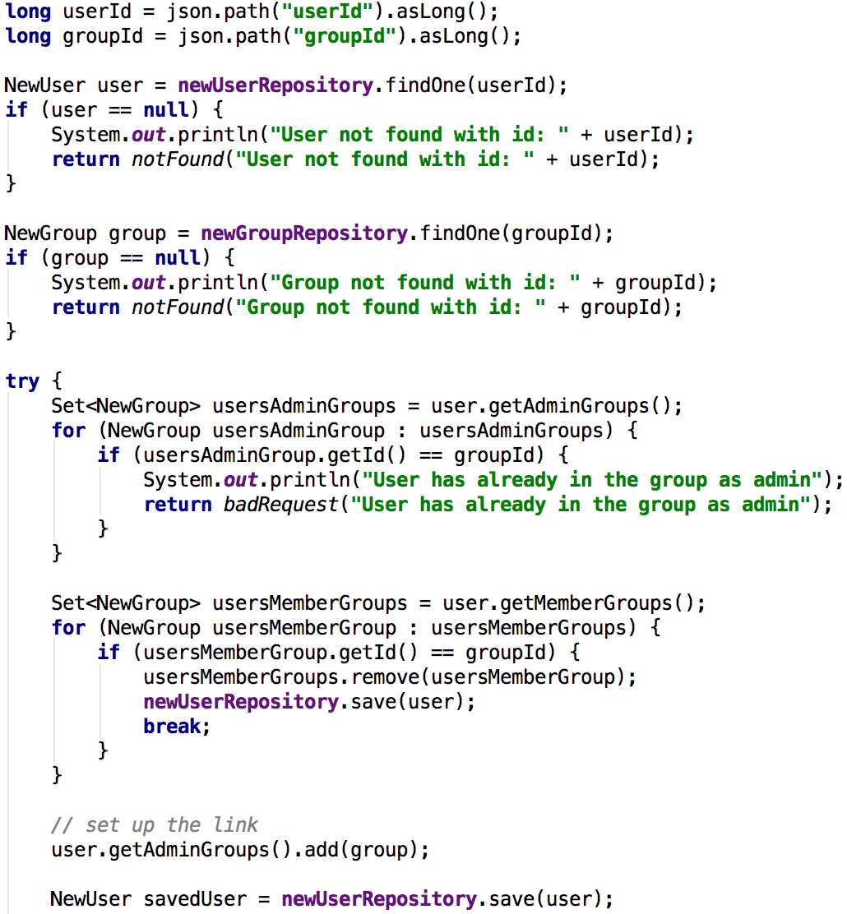

Figure ‑

## Friend List

A user has self-join many to many relationship to itself, this is how friend list feature is achieved (Figure 5-16)

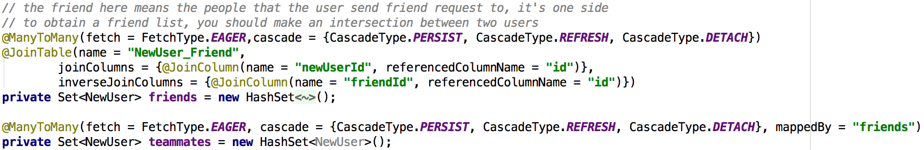

Figure ‑

Add a friend to a user and remove a friend from user is quite straightforward, we can get the friends field of the user, and add a user to or remove a user from the friends set.

However, what makes the project complicated is that once users are friends with each other, we cannot easily delete the user, since the users is referenced from other users. This will happen when user subscribe other users too. Furthermore, In this project, we want to make sure that when one user is deleted, his post should not be deleted as well. Therefore, I wrote a helper method to remove the user’s relationship with other entities, so the user can be safely deleted, please see Figure 5-17.

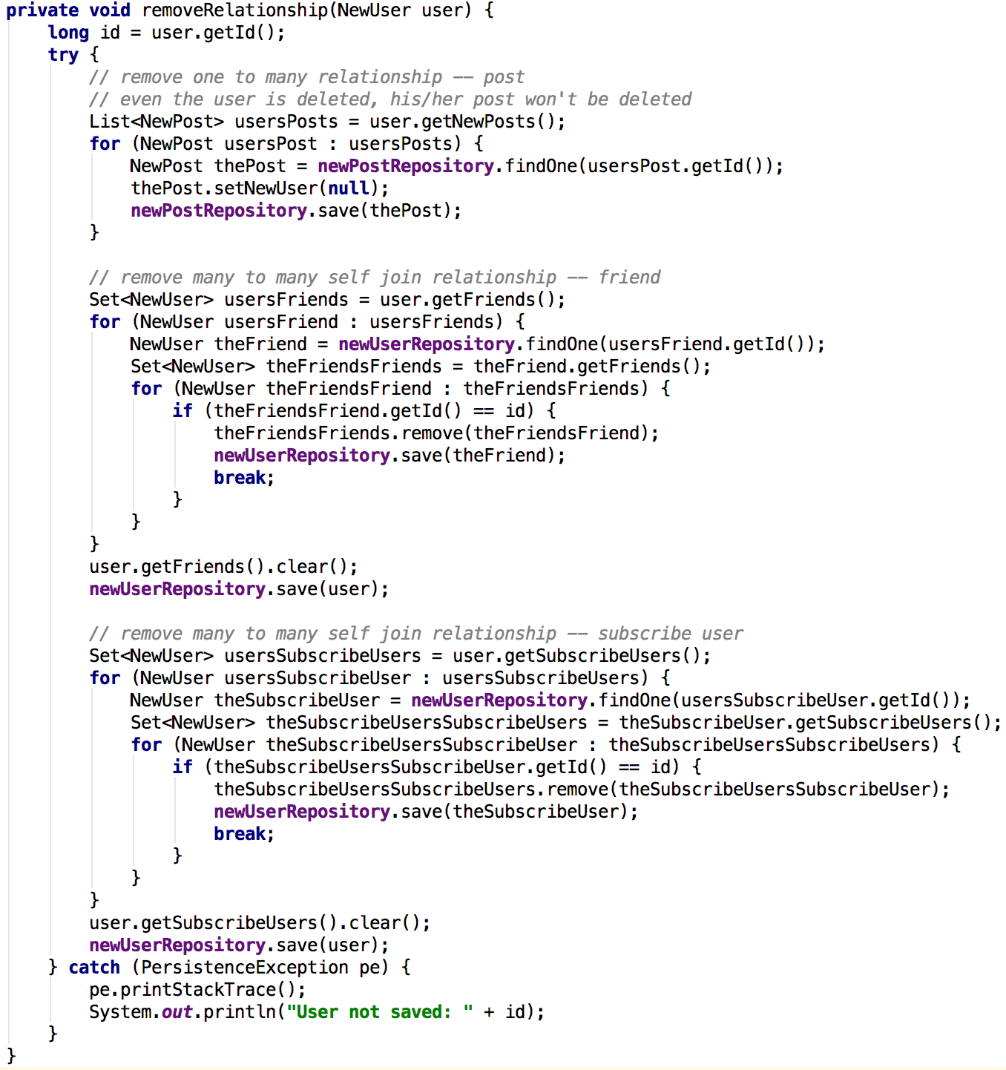

Figure ‑

This method is defined under the NewUserController.java, you should call this method whenever you want to delete a user.

## Subscribe

The mechanism of subscribing a user is quite the same as add a user as a friend to one’s friend list. It’s also a self-join many to many relationship (Figure 5-18).

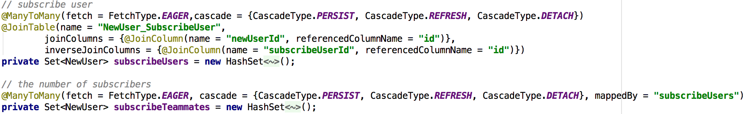

Figure ‑

For subscribing groups and workflows, they also have fields defined in user entity (Figure 5-19)

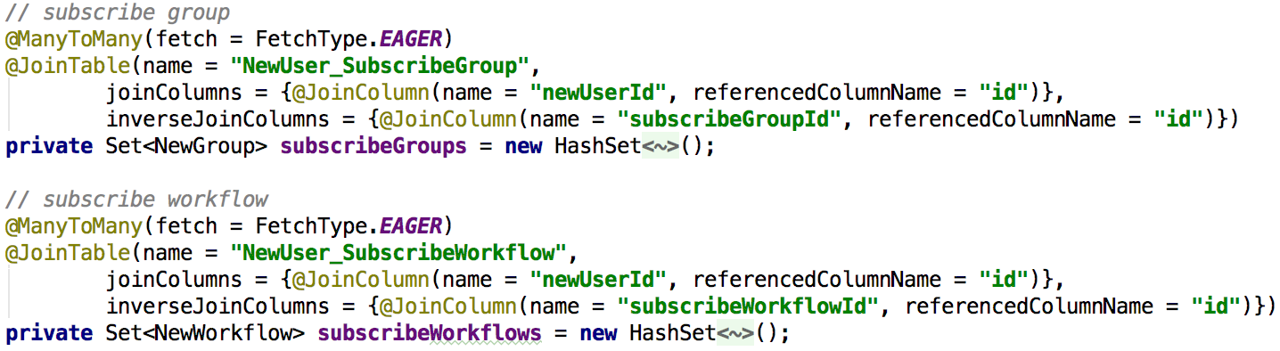

Figure ‑

## User Profile

A summary of user’s interests can be retrieve from the field of user’s entity as describe in chapter 5.3. A list of workflows that he/she is a contributor to can get from user entities’ newWorkflows set (Figure 5-20)

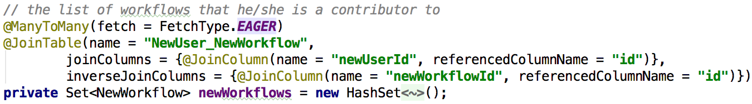

Figure ‑

The number of subscribers can be calculated by this method (Figure 5-21), and the number of collaborators can can be calculated by this method (Figure 5-22)

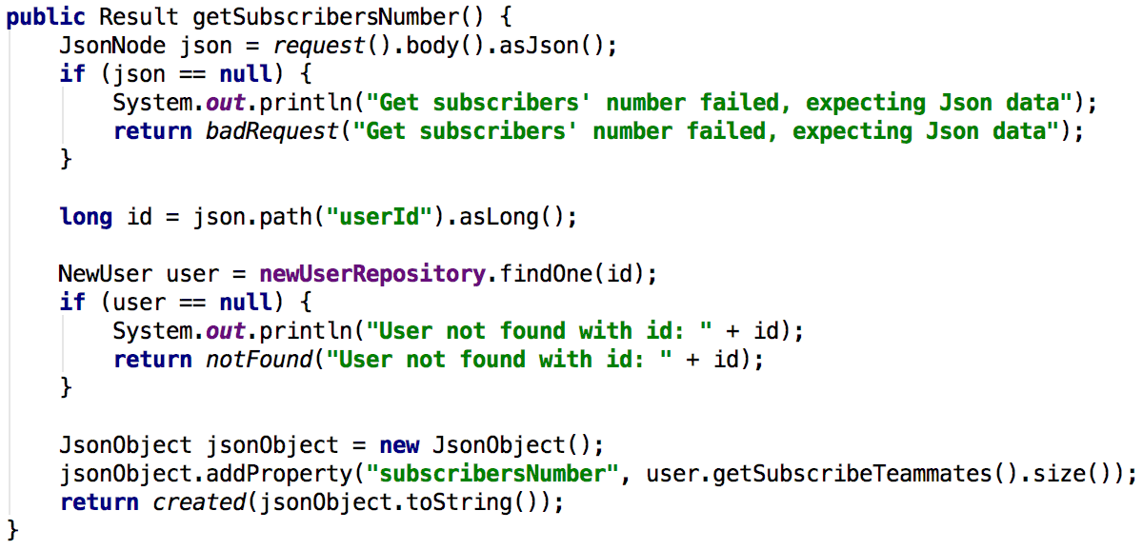

Figure ‑

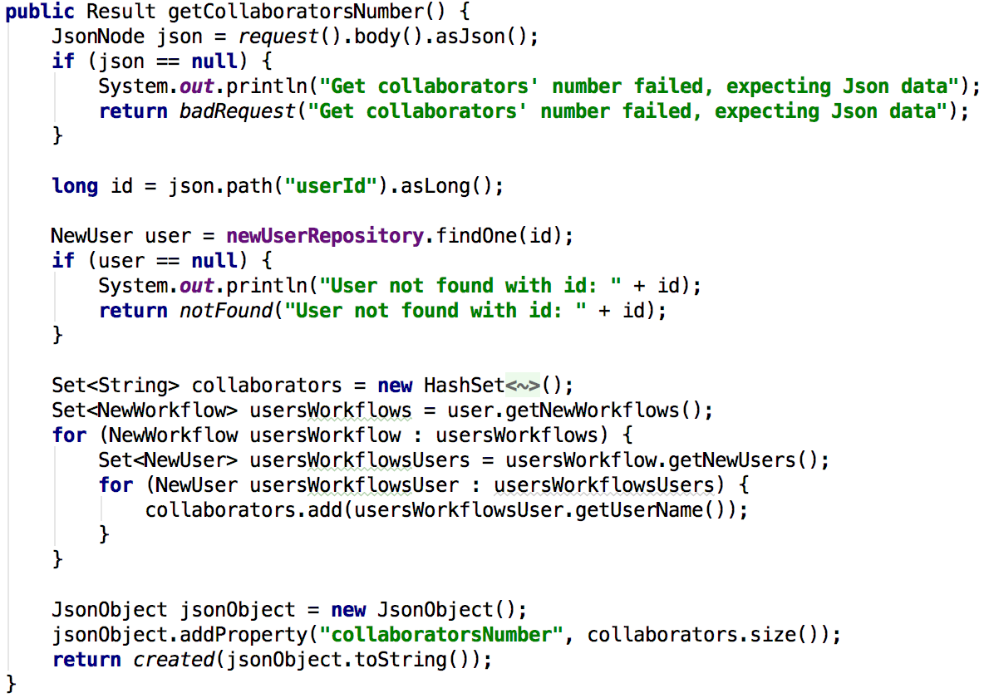

Figure ‑

The tags that he/she is most associated with either in posts and workflows can be calculated by the following steps:

Step 1: get all the workflows and posts of the user (Figure 5-23)

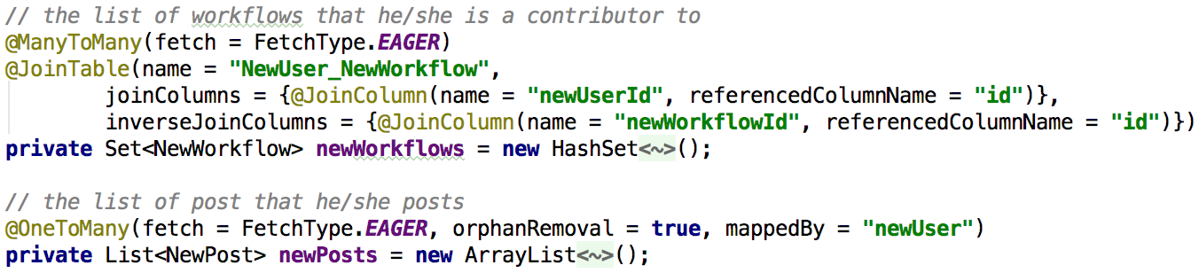

Figure ‑

Step 2: get all the tags under the workflows and posts (Figure 5-24, Figure 5-25)

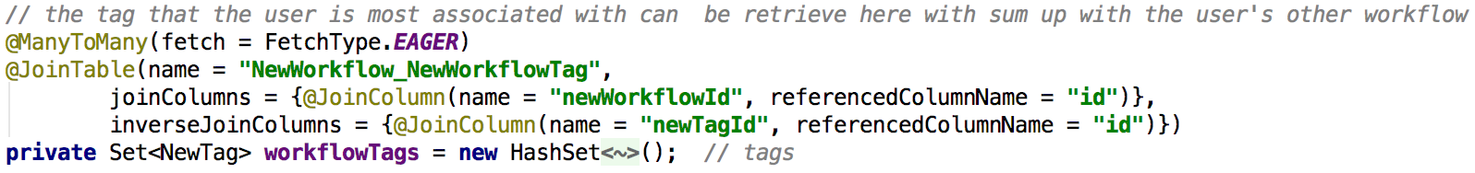

Figure ‑

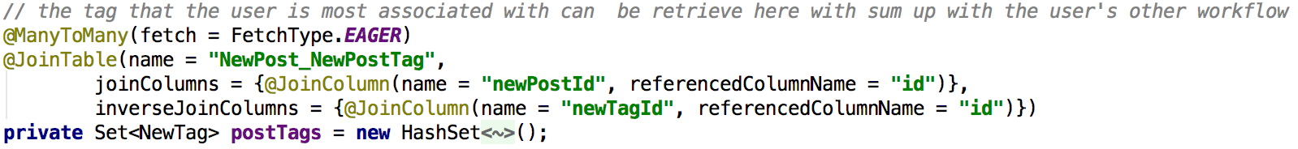

Figure ‑

Step 3: Sum up these tag and find the most popular tag of this user.

## Tagging

Tagging has been described in Chapter 5.1, you can call /workflow/addTagToWorkflow and /post/addTagToPost API to add tags, to search by tag, you can first find the tag instance, and then get the workflows and posts under this tag.

## Forums

I choose structure #1 to implement the forum feature, all posts in this project are organized as one discussion tree with a single root associated with a workflow, group or service. The relationship between post and workflow/group/service is not defined through the relationship between the tables, instead, I use two fields in the post table to specified the relationship (Figure 5-26). The “domain” field in the post table can only have one of these three values: workflow, group or table, which defined where the post belongs to. The second field is the “domainName”, this field records the corresponding workflow’s name, group’s name or service’s name that map to this post.



Figure ‑

## Discussion or Question

In the post entity, the isQuestion field is used to mark whether a post is a discussion or a question (Figure 5-27).

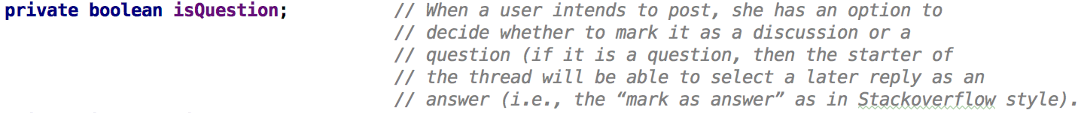

Figure ‑

In Figure 5-28, the isAnswer field under the NewReply.java is used to marked whether the reply is the answer.

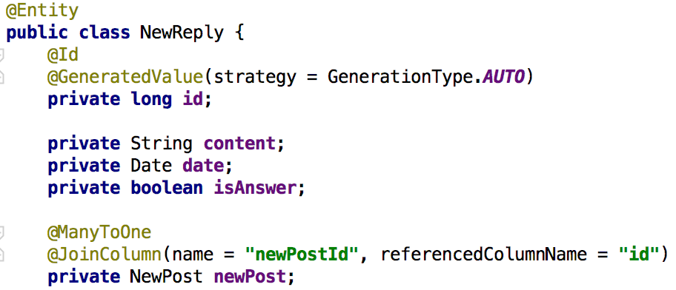

Figure ‑

## Moderator Rights

Moderator right is implement in the field of questionableCount under the workflow and post entity (Figure 5-29). When user find the content of the post or workflow questionable, the user can add the questionableCount to flag the content to be questionable.



Figure ‑

# Experiment and Analysis

In this chapter I will show the step a user create workflow and post a new post under this workflow, furthermore, we will reply on this post. Detail usage and test case can be found in the API of this report’s appendix.

Step 1: we need a user account, so we first register a new user (Figure 6-1), now we know the user’s id is 1.

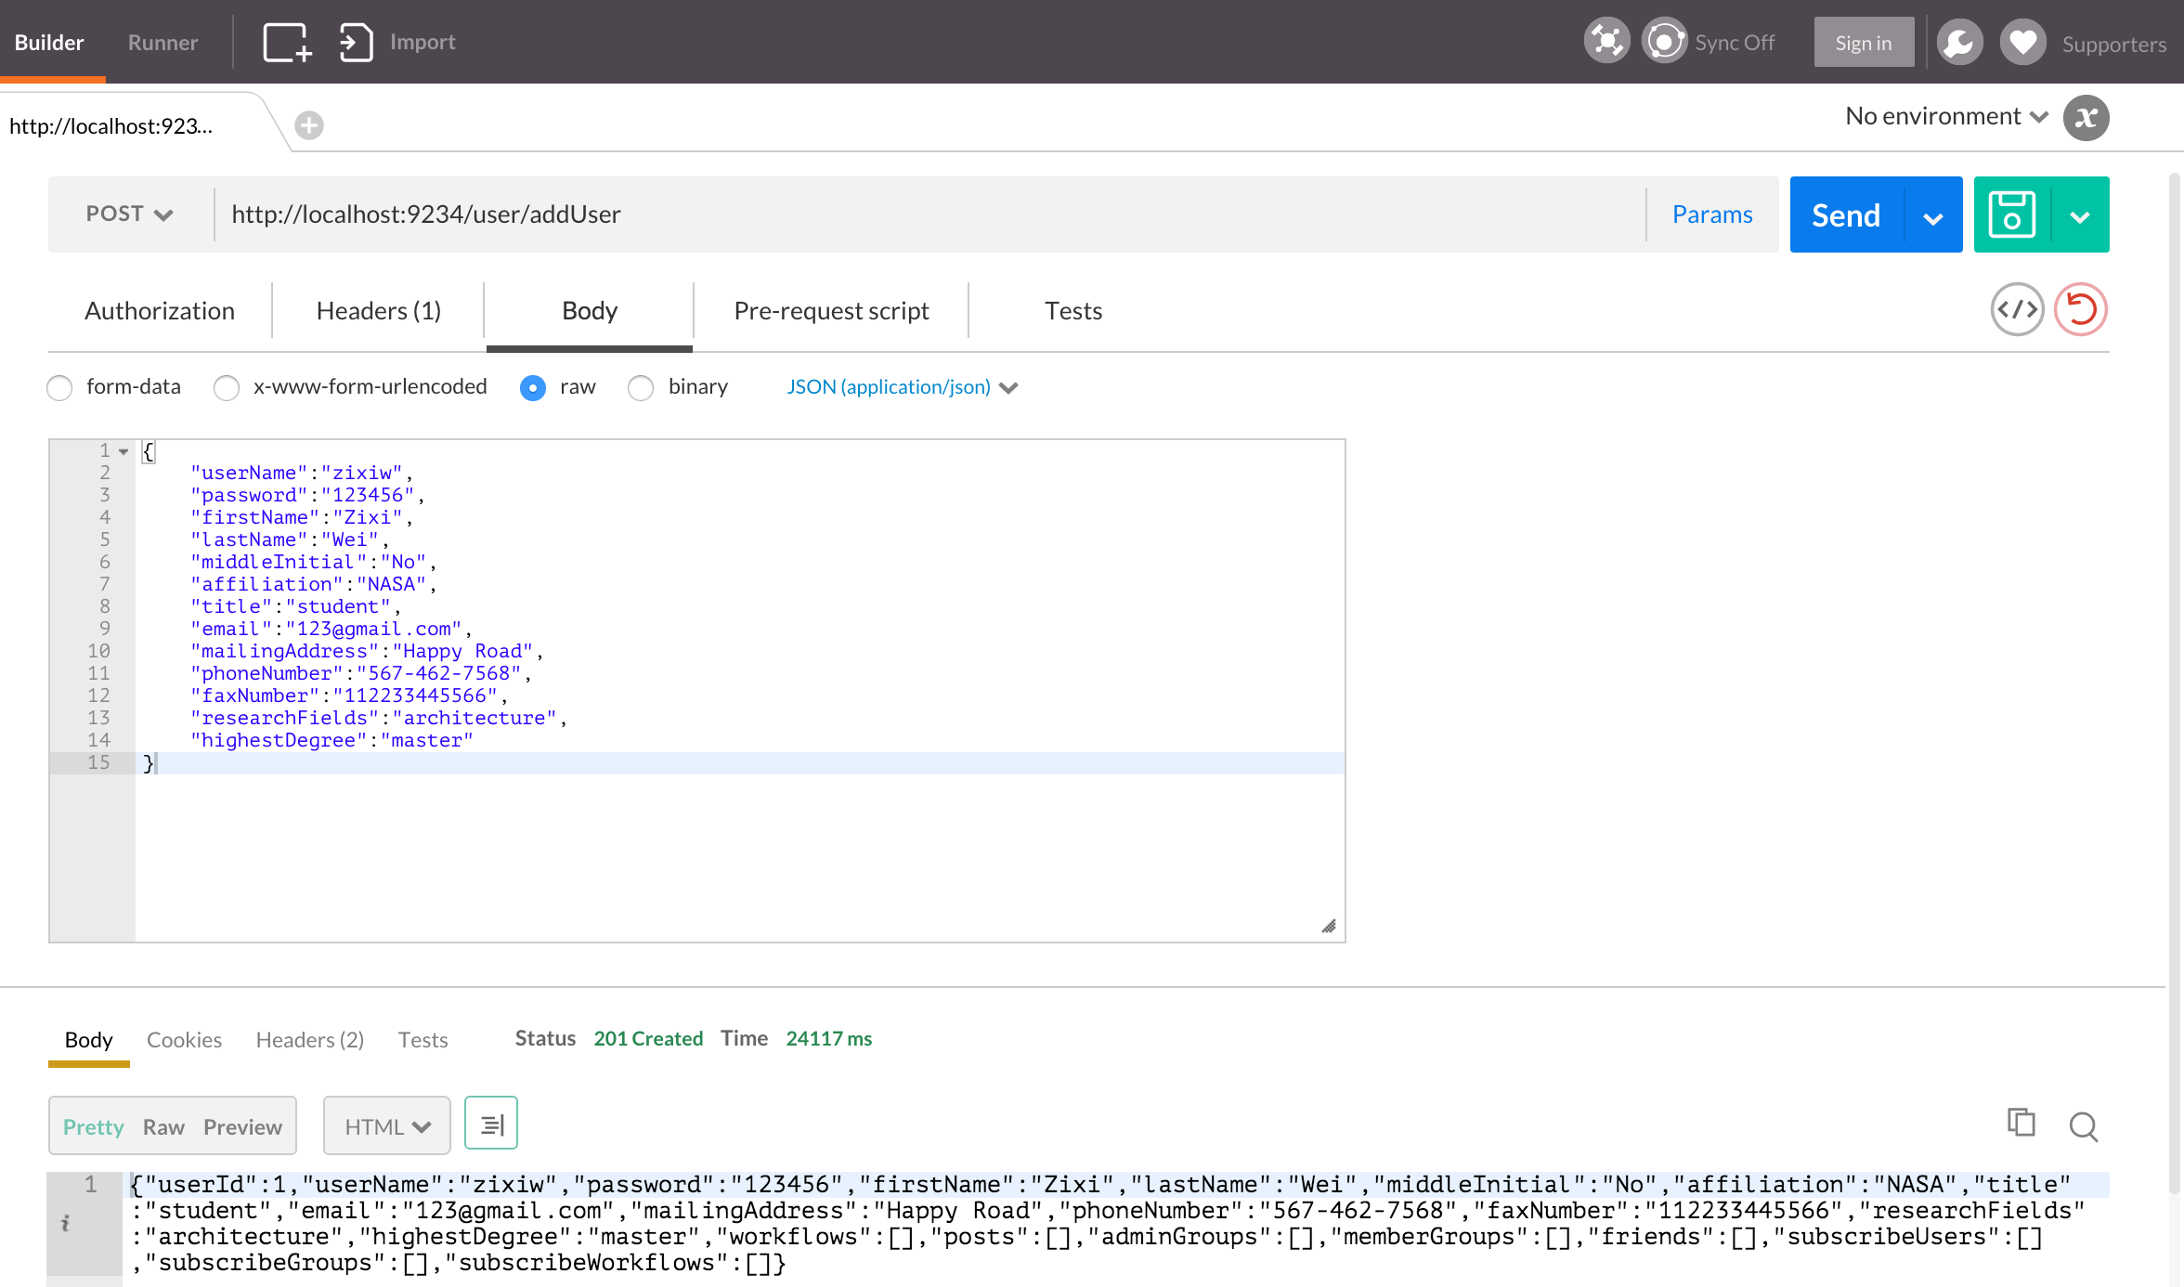

Figure ‑

Step 2: create a basic workflow (Figure 6-2)

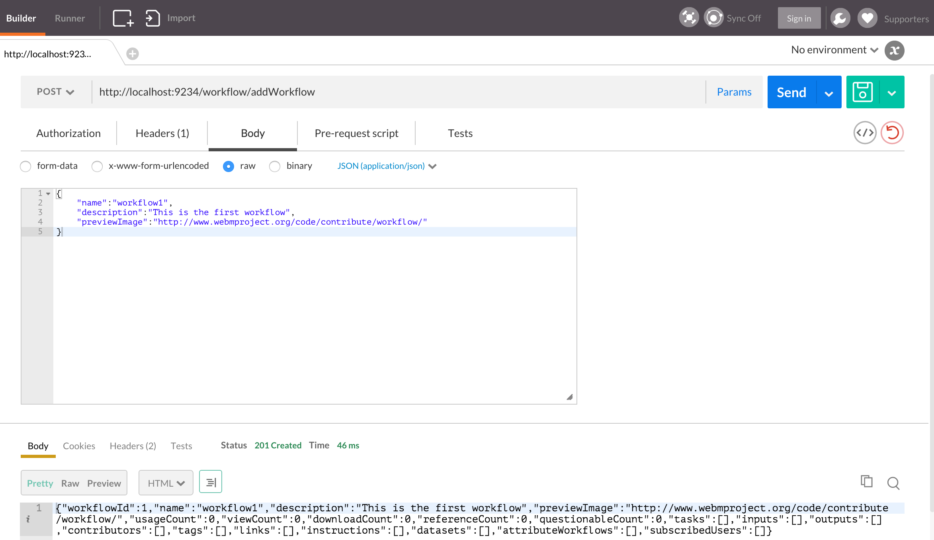

Figure ‑

Step 3: from Figure 6-2, we can see that the workflow only has some basic information. To add tasks, inputs, outputs contributors, tags, links, instructions, datasets, attributeWorkflows, subscribedUsers to this workflow, we first need to creat the corresponding instance, then add it to this workflow. In this step I will show how to add task to this workflow, adding other elements are the same way as adding tasks. Now we need to create a new task (Figure 6-3)

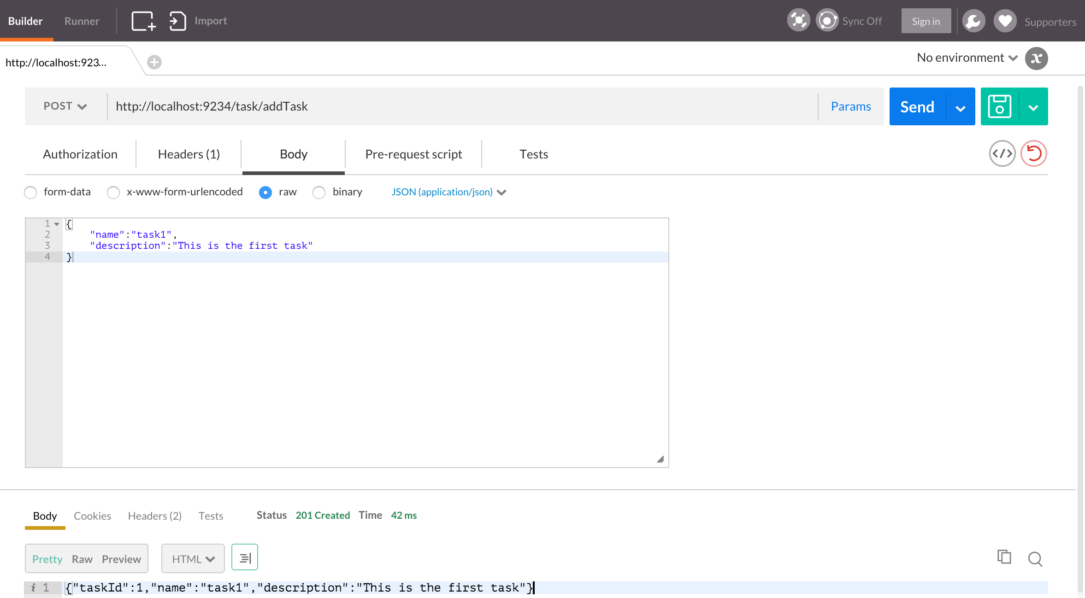

Figure ‑

Step 4: adding the task to the workflow (Figure 6-4), now when you get the workflow by workflow’s id, you will find this workflow contains the task we just added (Figure 6-5)

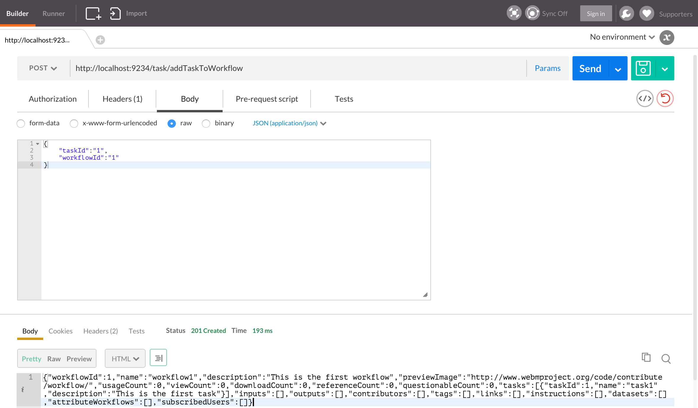

Figure ‑

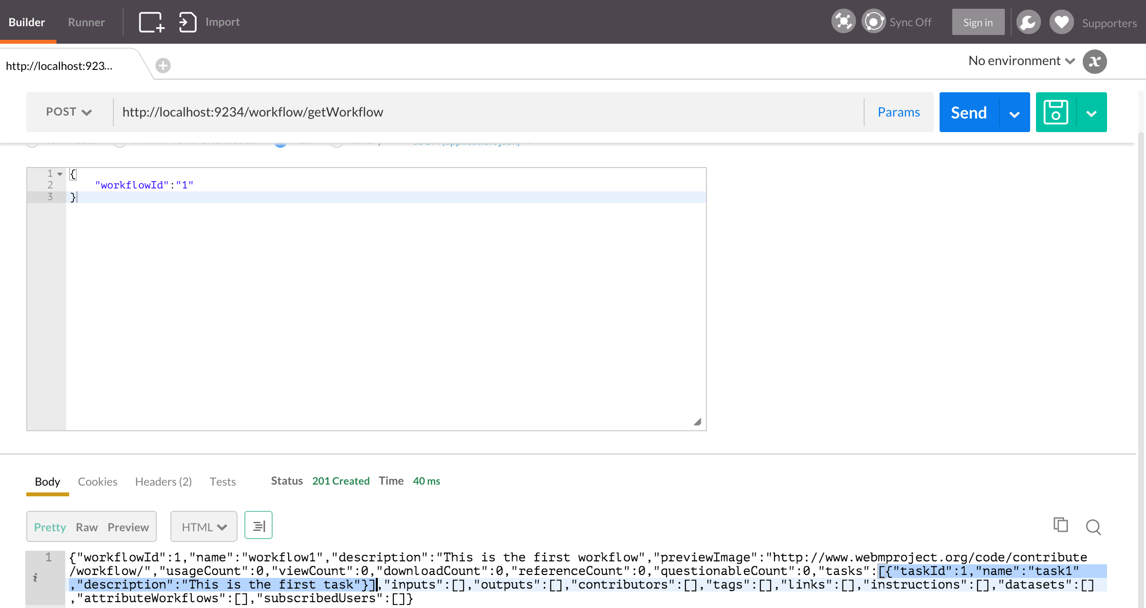

Figure ‑

Step 5: add user to workflow, so the user owns this workflow, and this workflow contains this user (Figure 6-6)

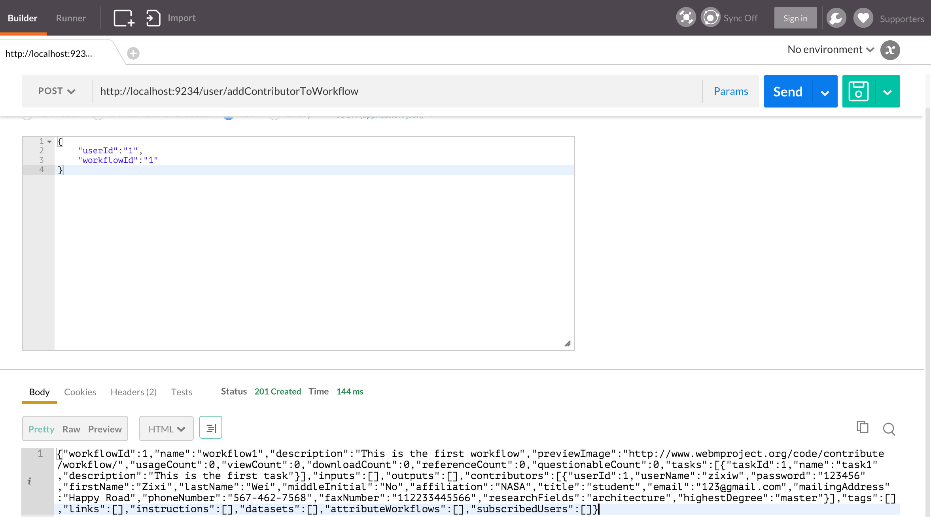

Figure ‑

Step 6: now we want to create a post under this workflow (Figure 6-7), the post and the workflow are linked by the domain and domainName. We can easily get all the post using domain and domainName (Figure 6-8).

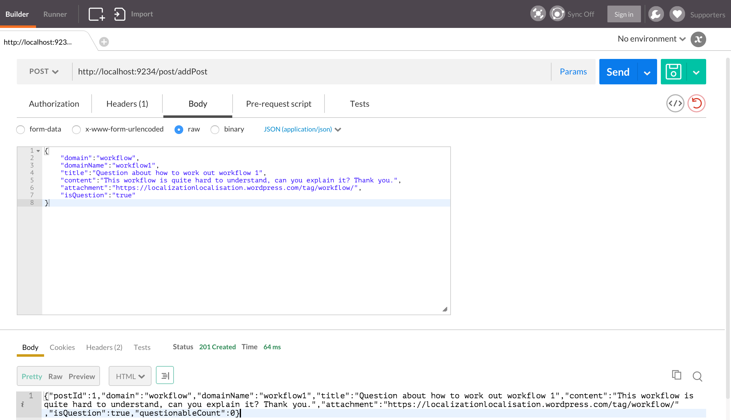

Figure ‑

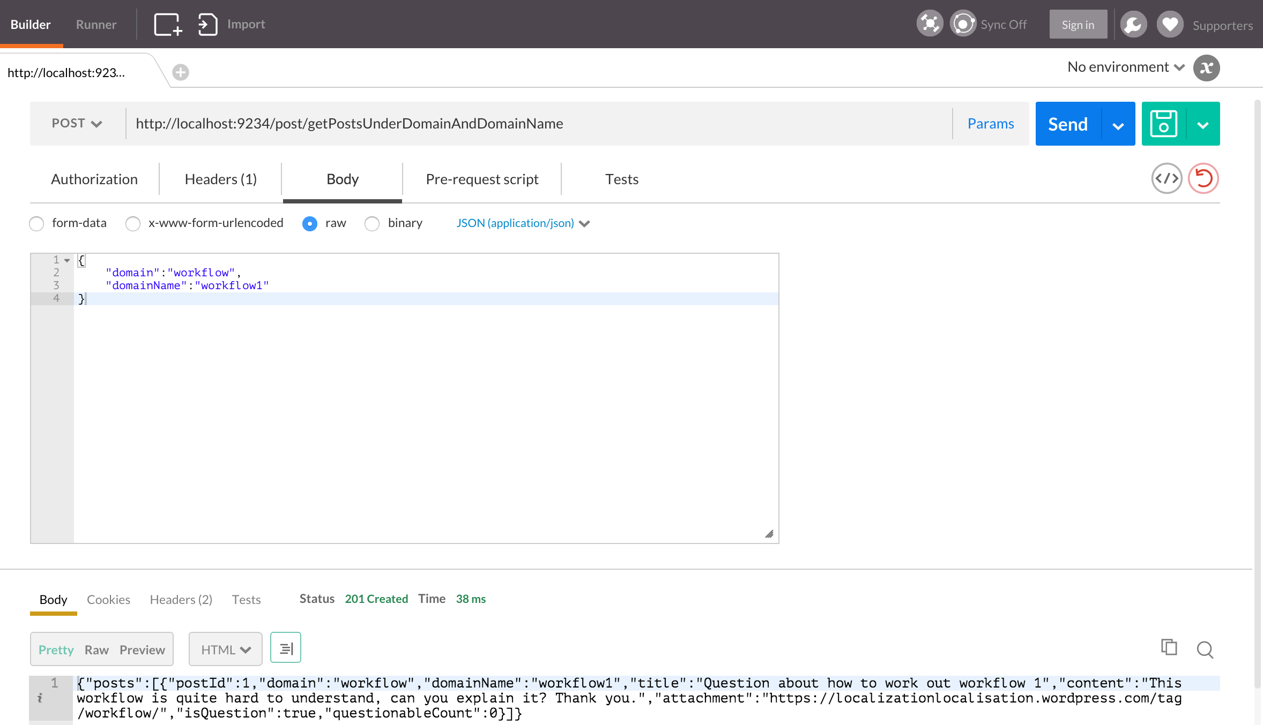

Figure ‑

Step 7: after created the post, we need to add this post to the creator (Figure 6-7)

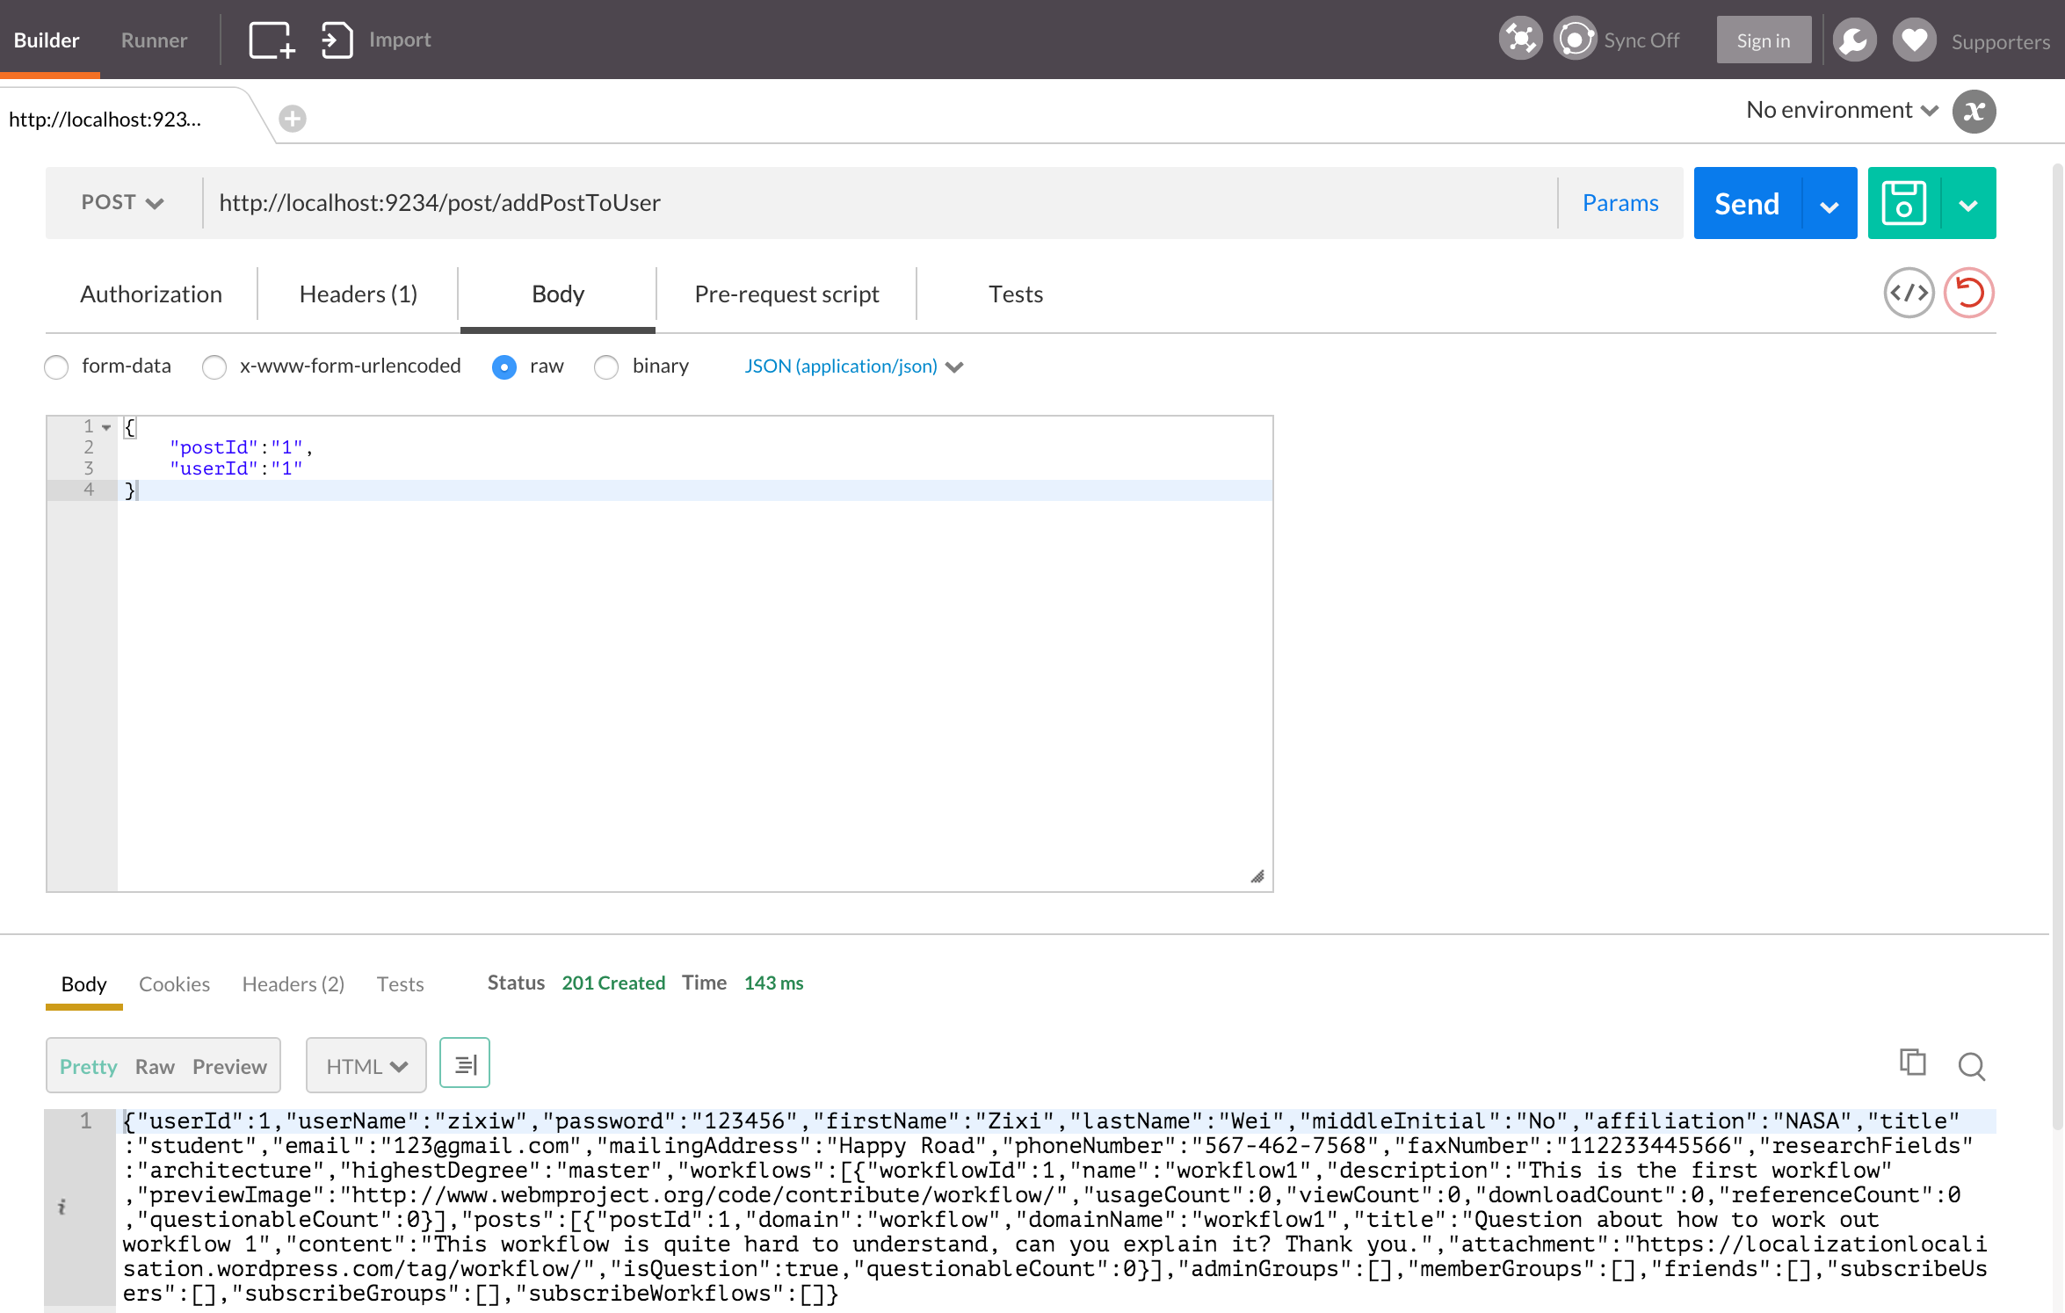

Figure ‑

Step 8: we will create a reply to this post, first wee need to create a reply instance (Figure 6-10).

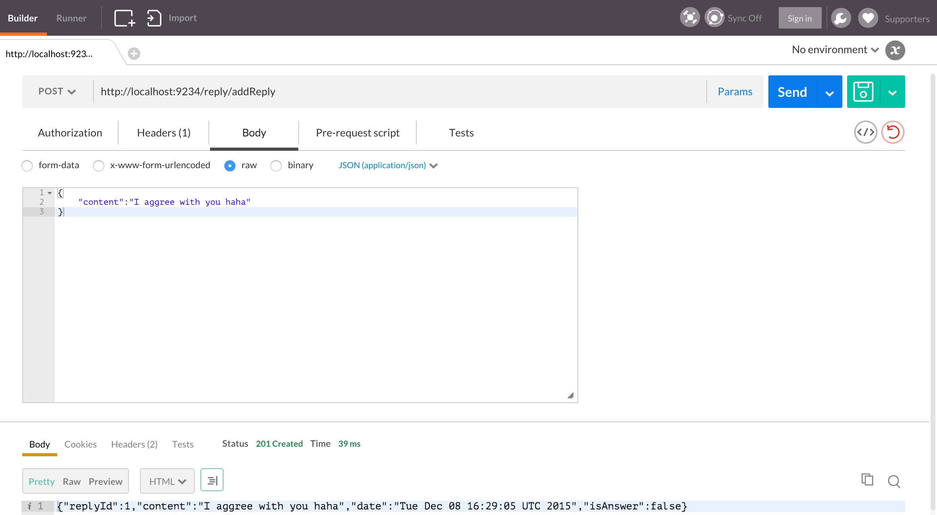

Figure ‑

Step 9: last step, add the reply to the post (Figure 6-11)

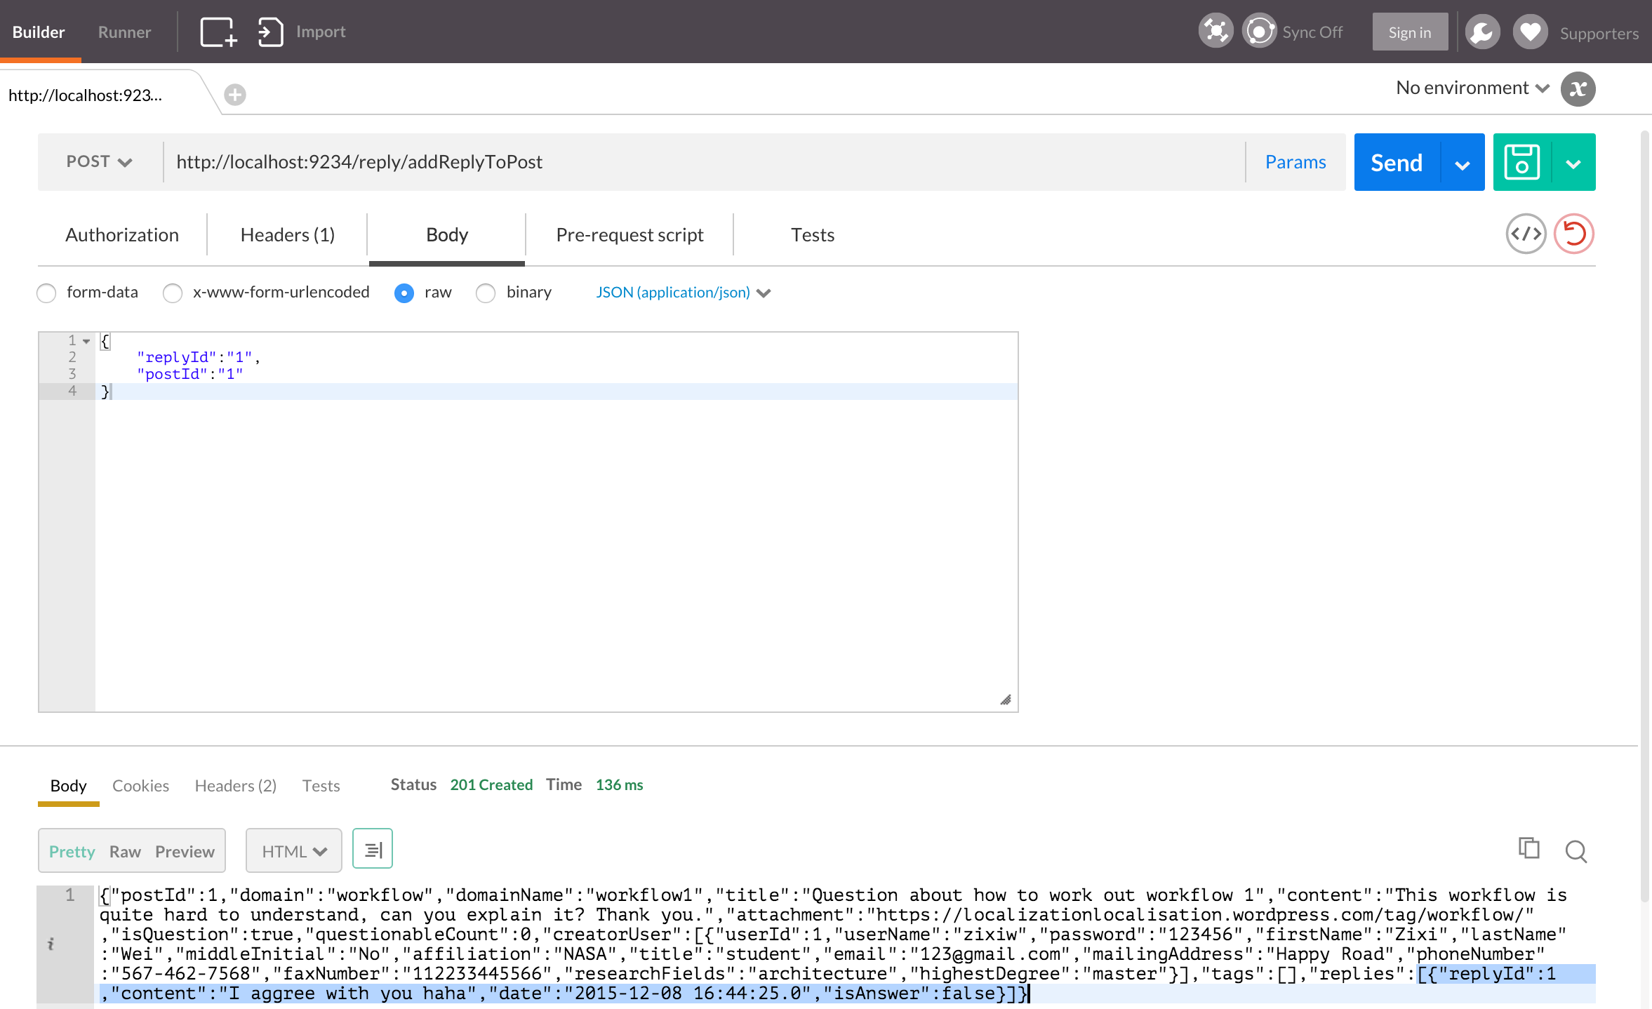

Figure ‑

# Conclusions and Future Work

In this project, we implement all the features required by the feature list, knowledge implementations include Play framework, Hibernate, Docker environment as well as Github version control. For the moderator rights feature, we only records the number that user flag the post or workflow as questionable, so we cannot find out who flag this content to be questionable, this is where we can improve in the future.

# Contribution of Each Team Member

|  |  |
| --- | --- |
| Name | Contribution |
| Zixi Wei | Database schema design, explore hibernate many to many features, construct code framework, code integration and quality control |
| Sen Yue | Database schema design, explore hibernate one to many features. |
| Mingyang Ling | Database schema design, , explore hibernate many to many features. |
| Zheng Lei | Database schema design, write test case. |

# Tutorial

Step 1: Clone the project from Github using git clone command to your computer (Figure 9-1). Repository link: <https://github.com/zixiw/SOC-Fall-2015-Team5-Lead-Zixi-Wei>

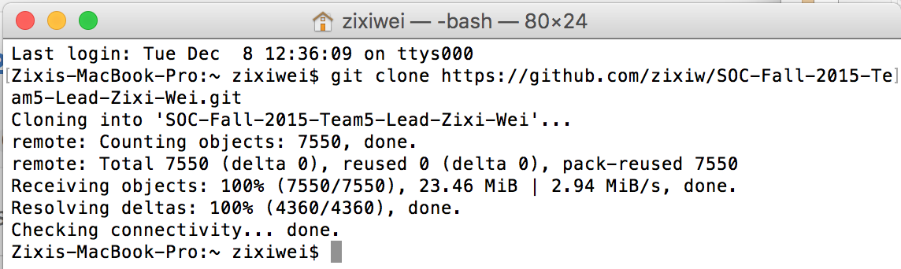

Figure ‑

Step 2: Install IntelliJ IDEA Ultimate Edition, you can use your student account to get the free edition (Figure 9-2). Download link: <https://www.jetbrains.com/idea/buy/#discounts>

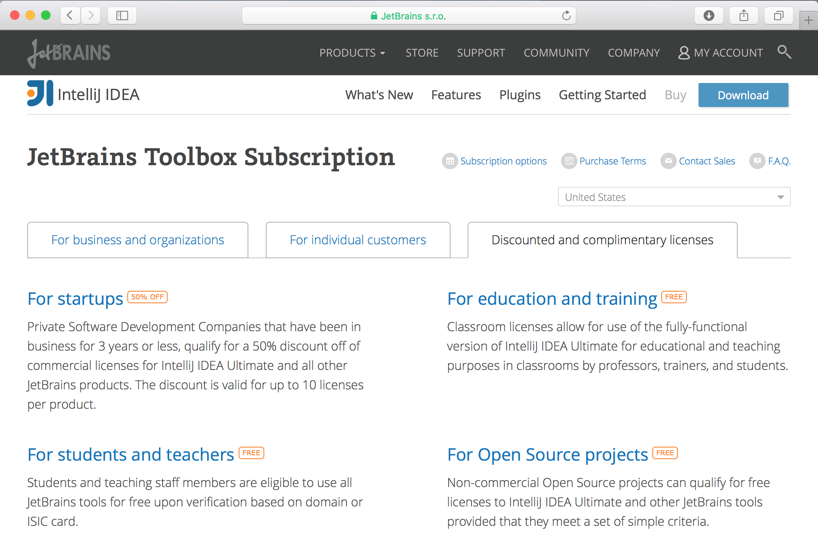

Figure ‑

Step 3: Import ApacheCMDA-Backend to IntelliJ. Open IntelliJ, select Import Project, browse to the ApacheCMDA-Backend directory under the SOC-Fall-2015-Team5-Lead-Zixi-Wei folder, click OK (Figure 9-3)

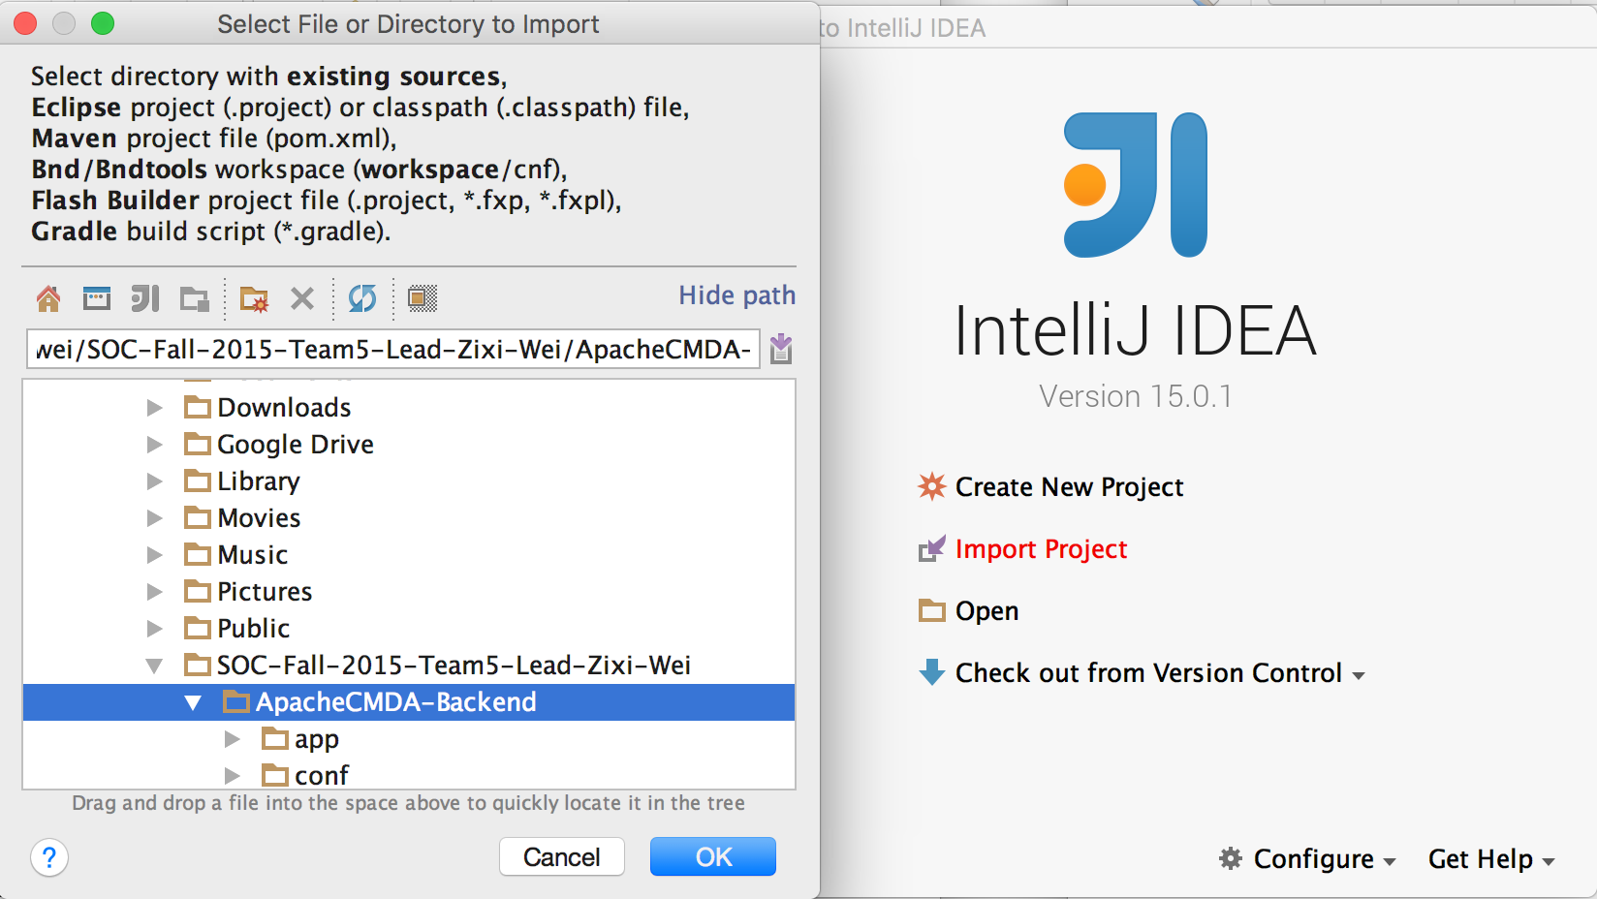

Figure ‑

Make sure you Import project from external model of SBT (Figure 9-4)

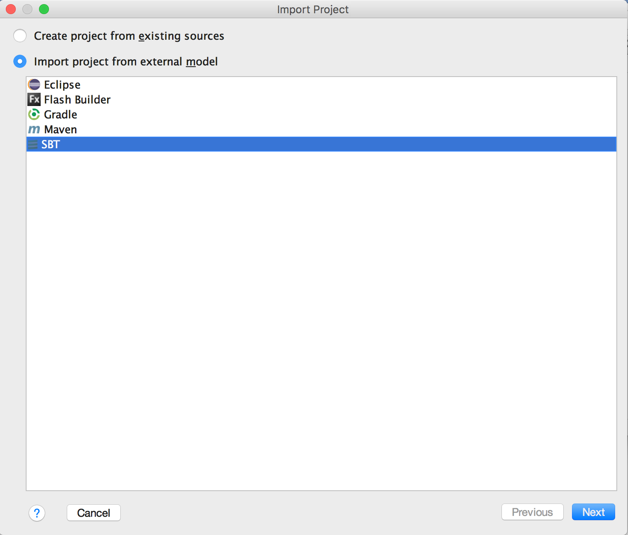

Figure ‑

Click Next, check “Use auto-import”, “Download sources and docs” and “Download SBT sources and docs” (Figure 9-5), then click Finish.

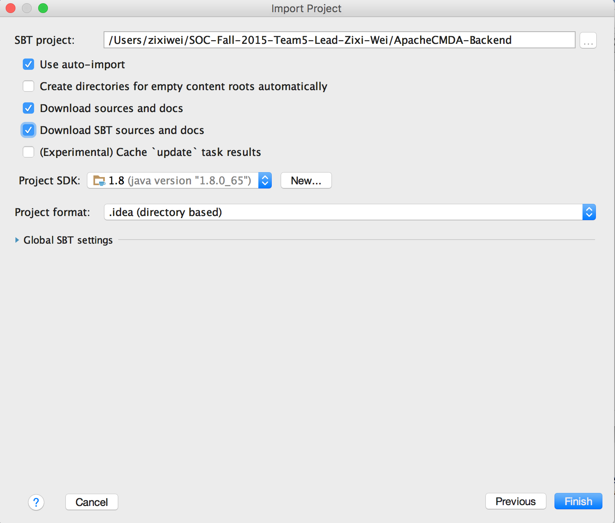

Figure ‑

Click OK (Figure 9-6)

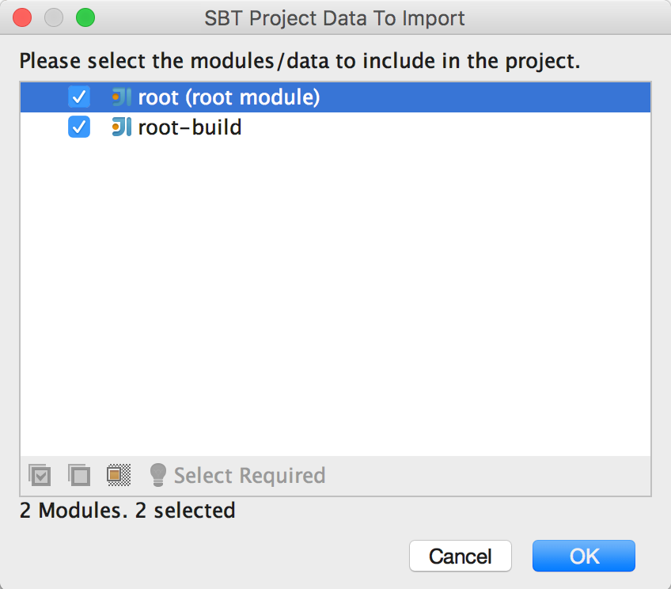

Figure ‑

Click Configure to configure JPA framework (Figure 9-7), click OK (Figure 9-8)

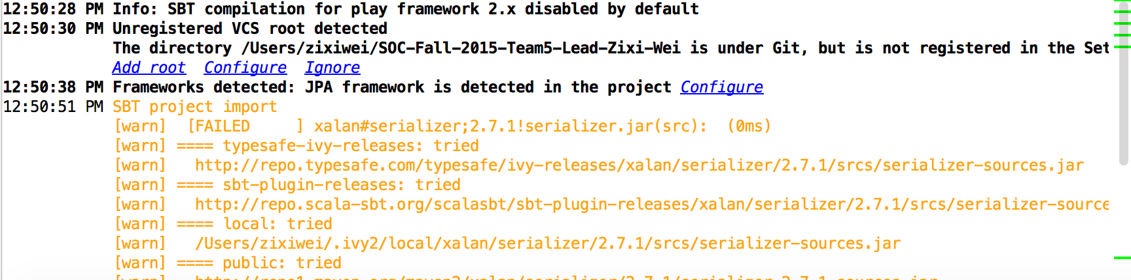

Figure ‑

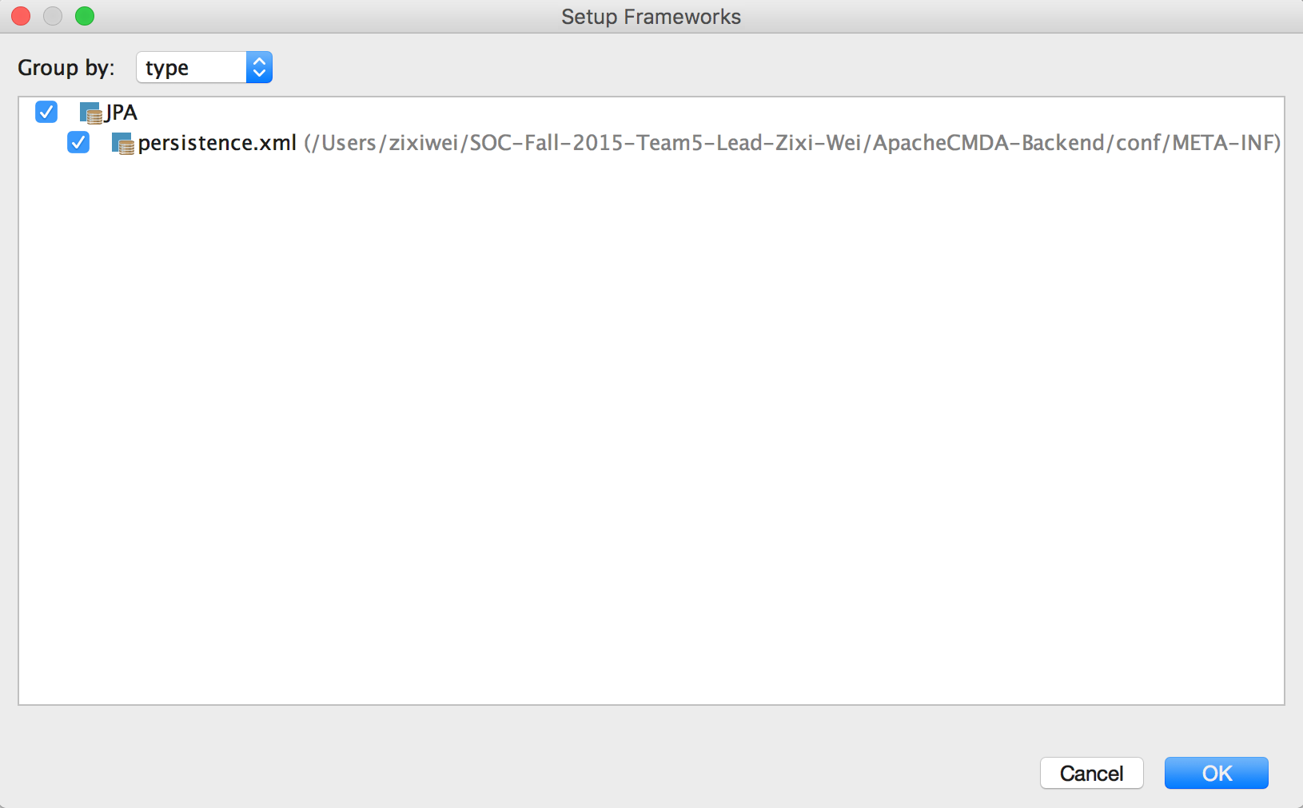

Figure ‑

Under IntelliJIDEA menu, choose “Preferences”, choose Play2 under the Languages & Frameworks, check “Use Play 2 complier for this project” (Figure 9-9), then click OK. The project now is successfully imported.

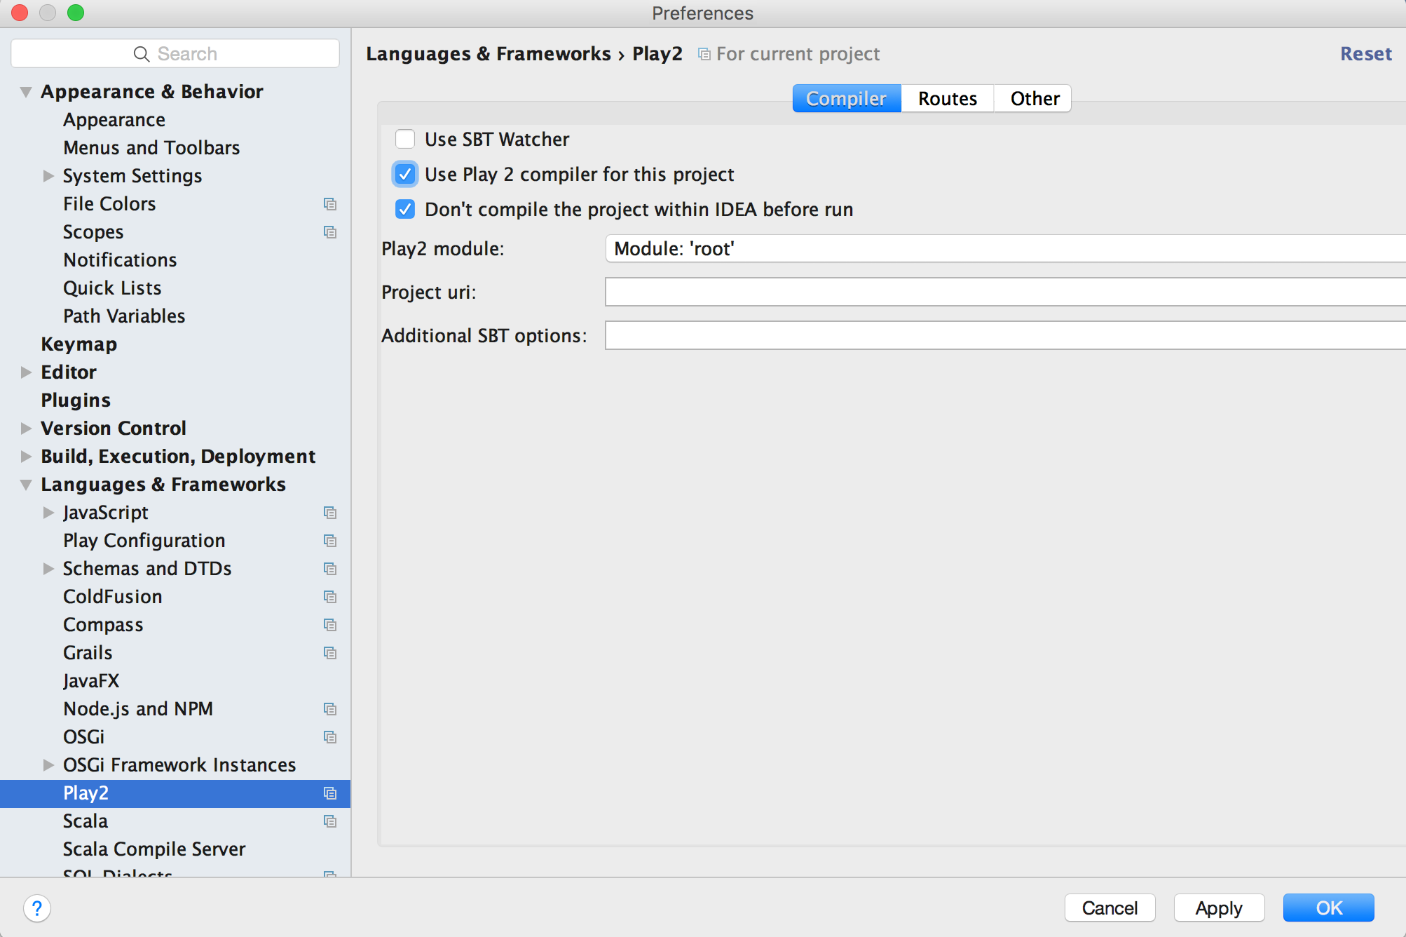

Figure ‑

Step 4: Setup Docker environment according to the Docker’s official guide: <http://docs.docker.com/mac/step_one/>

Step 5: Open Docker quick start terminal, run docker pull cmusvsc/apachecmda:1.0, to pull the image from Docker Hub, then use docker images command to check whether the image is pulled successfully (Figure 9-10).

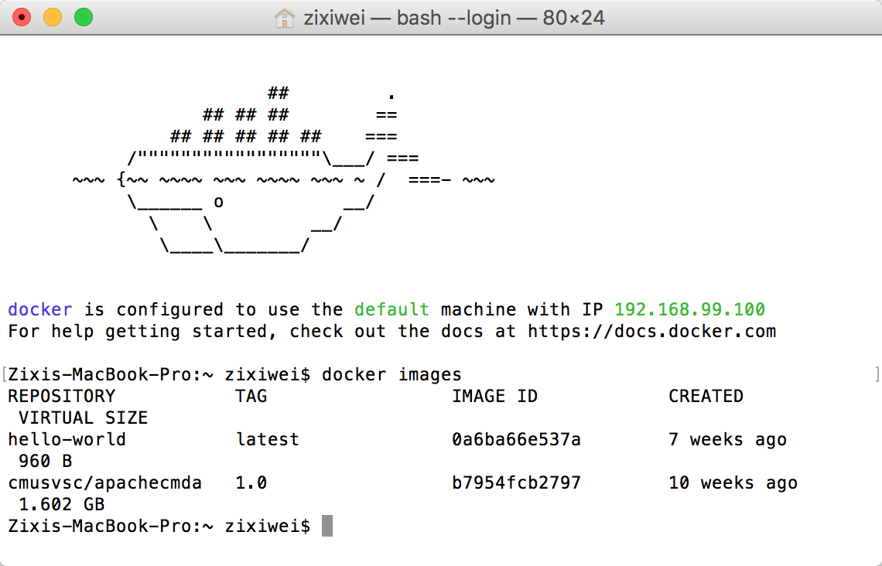

Figure ‑

Step 6: Mount your local directory to the /home/SOC-Fall-2015 directory inside the container (Figure 9-11):

docker run -it -p 9234:9000 -v /Users/zixiwei/SOC-Fall-2015-Team5-Lead-Zixi-Wei:/home/SOC-Fall-2015 cmusvsc/apachecmda:1.0

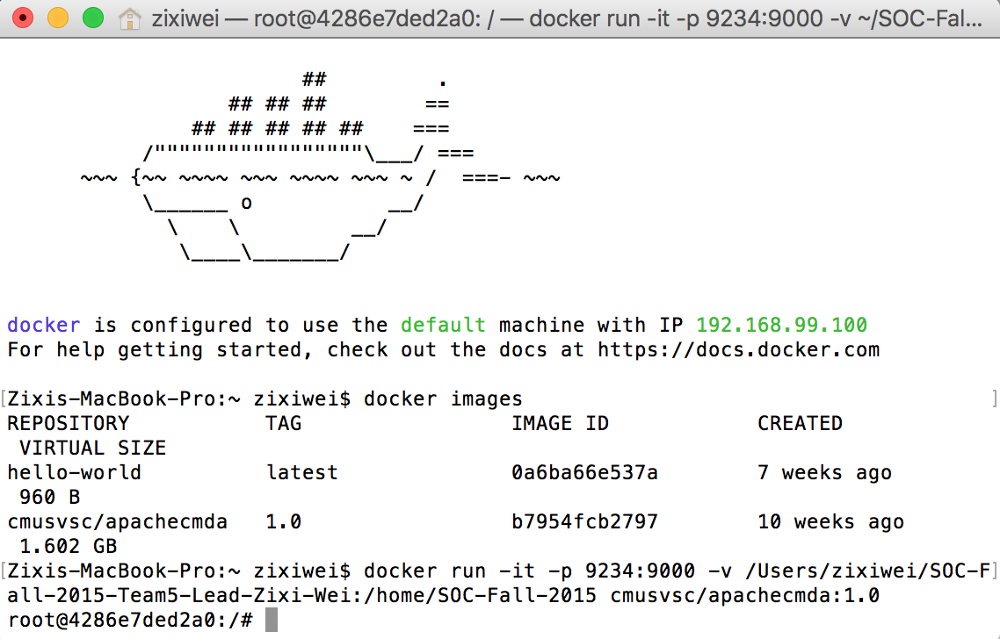

Figure ‑

Step 7: Start MySQL service using “service mysql start” (Figure 9-12)

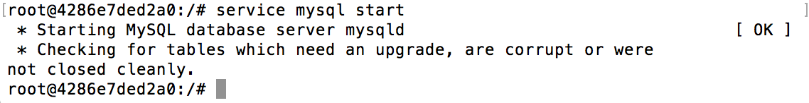

Figure ‑

Step 8: Start the backend. Cd into the ApacheCMDA-Backend directory, start the backend by using “./activator run”, now the backend has started (Figure 9-13)

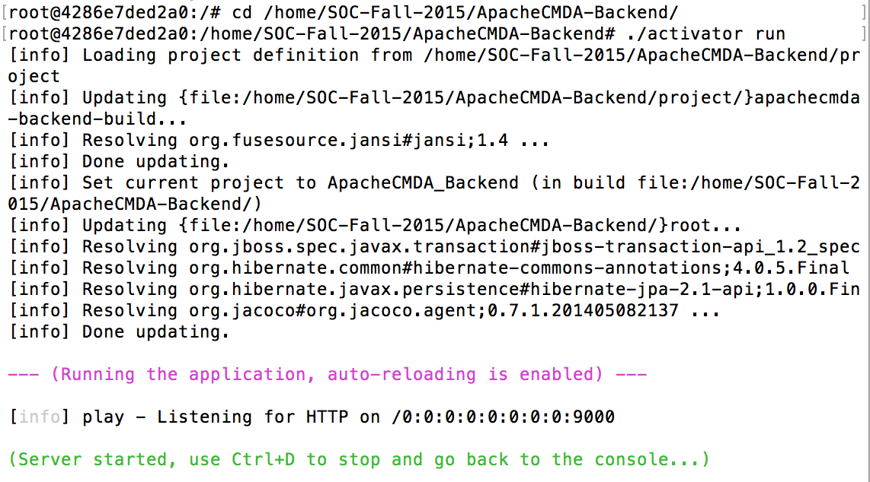

Figure ‑

Step 9: Try the first POST. Open the routes file under the conf folder in ApacheCMDA-Backend in IntelliJ, you will find a list of routes that you can use to communicate with the backend. Please only use the routes below the # Newly Added comment. (Figure 9-14)

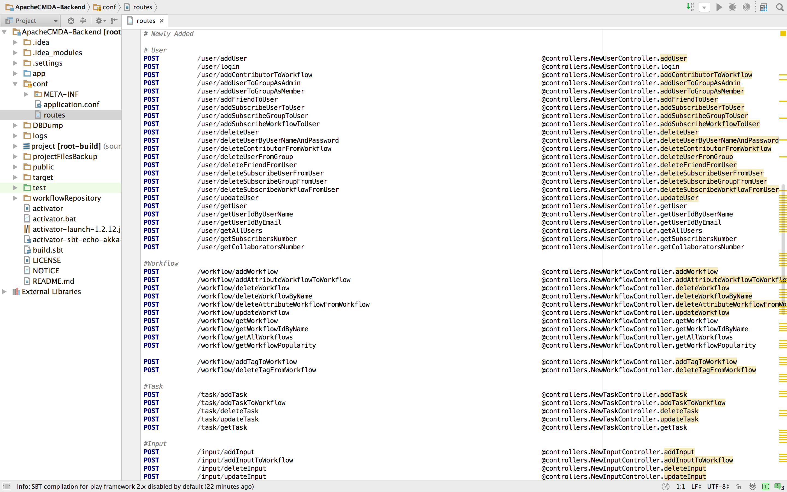

Figure ‑

For detailed usage, please refer to the API of the Appendix (Figure 9-15)

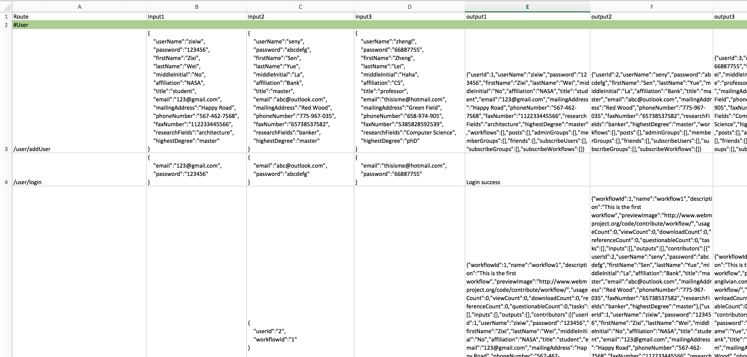

Figure ‑

Now let’s register a user. Open Postman, choose POST, type in the url: <http://localhost:9234/user/addUser>

Open the Body menu, choose raw and set the input as JSON(application/json), paste the following JSON data to the input blank:

{

"userName":"zixiw",

"password":"123456",

"firstName":"Zixi",

"lastName":"Wei",

"middleInitial":"No",

"affiliation":"NASA",

"title":"student",

"email":"123@gmail.com",

"mailingAddress":"Happy Road",

"phoneNumber":"567-462-7568",

"faxNumber":"112233445566",

"researchFields":"architecture",

"highestDegree":"master"

}

Then click Send, after a few while, you will get a message to tell you that user added success. (Figure 9-16), Figure 9-17 is the output on the Docker terminal.

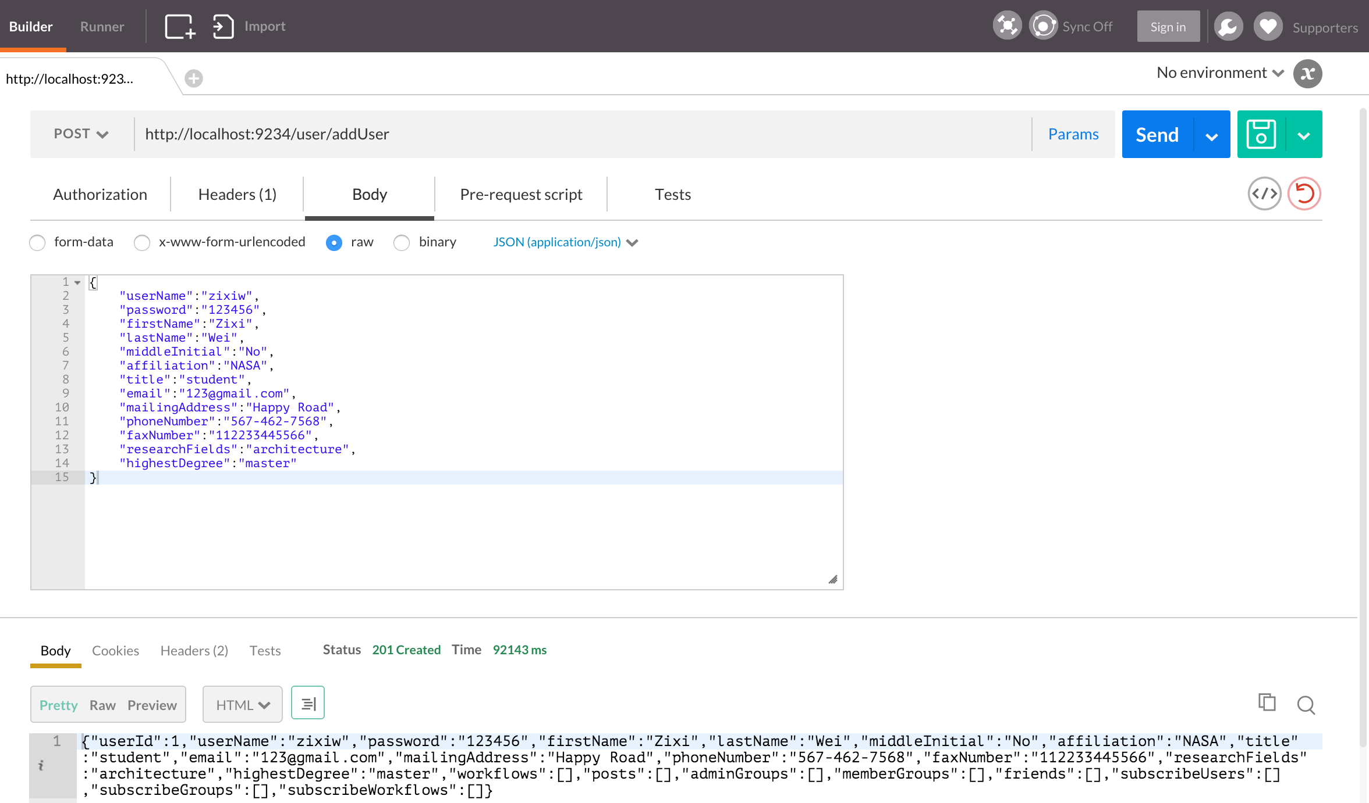

Figure ‑

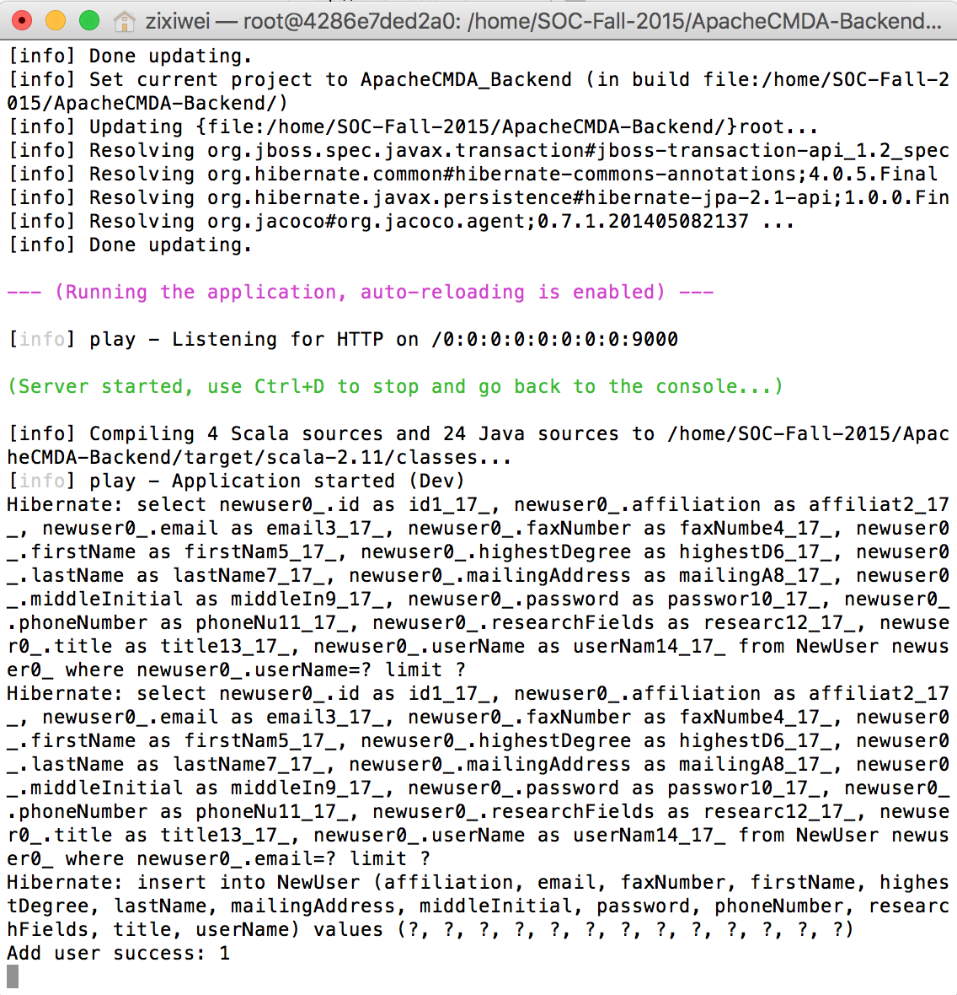

Figure ‑

# Appendix

-Check in everything onto GitHub under the predefined directory including the following items

-Readme file: Describe briefly the purpose of the project, how to download and install the software, how to use the software

-API (sub-directory): instruct APIs as well as descriptions and examples

-Test Suite (sub-directory): a collection of test examples and descriptions

-src (sub-directory): include all source code categorized by packages

-lib (sub-directory): include all related library packages needed to support the project

-conf (sub-directory): include any confirmation settings and files

-app (sub-directory): any applications built on top of the APIs

-contact: please provide every team member’s contact information (cell number, personal email)

-Check in everything onto DockerHub under the predefined directory

-Documents (sub-directory): in different WORD files

-access information: URL, user name/password

-download and installation documents with step-wise descriptions

-executive summary

-background and motivation

-assumptions and considerations

-design documents (architectural design documents and various diagrams e.g., UML files)

-discussions

-presentations (ppt file)

-tutorial: step-by-step usage file with screen shots included

-future work: to-do list and descriptions

-technical report

-Transit the knowledge to either Advisor or a signed student (schedule time to sit down for transition)